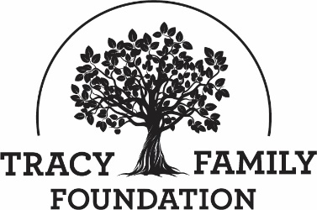
Multi-Year Project and/or Program Guidelines
Originally Approved: July 27, 2022

Introduction | TFF typically requires an organization to submit a full application for funding every year even if a project and/or program spans multiple years. These guidelines are intended to outline a process by which a trusted organization would not need to complete the full TFF application every year for the same project and/or program but could instead submit a grant application for a multi-year project and/or program. Allowing an organization to submit one full application for a multi-year project and/or program would allow the organization to spend more time on their mission and less time on TFF applications, create a more personalized TFF evaluation process of the project and/or program each year, offer the organization financial stability, and increase the organization’s ability to plan complex, multi-year efforts.
Eligible Organizations | Only organizations invited by TFF staff to submit a grant application for a multi-year project and/or program will be eligible. TFF Staff will only invite organizations that have applied for and received TFF Formal Funding awards for the same project and/or program for three or more years in a row. The invitation will be extended to the organization through a personal conversation with the organization’s leadership. The organization could decline the invitation and instead continue to submit a full annual grant application.
Multi-year Grant Application Process | Invited organizations will complete the TFF Formal Funding application and answer each question to cover up to a three-year period. In addition, the organization should submit a project budget and measurable goals and outcomes spreadsheet that covers each of the three years.
Grant Authorization | All grant applications for multi-year projects and/or programs will be reviewed by the TFF Board during a typical grant cycle.
Follow Up on Grant Awards | If the TFF Board awards an organization a grant for a multi-year project and/or program, the organization will not need to complete a full grant application each year of the project and/or program. Instead, the organization will submit an Annual Impact Report and TFF Staff will conduct a site visit. The TFF Executive Director is then authorized to approve the subsequent year’s grant only after these two steps have been completed and the TFF Staff are satisfied that the organization is implementing the project and/or program as intended in their original application. If additional funds are needed, or the project and/or program has substantially changed, the organization will need to submit a new full grant application.
After three years, the organization will be required to submit a new formal funding application to TFF. No extensions to grants for multi-year projects and/or programs will be permitted.
Internal Tracking | The first grant for a multi-year project and/or program approved by the TFF Board will not create a liability for TFF in subsequent years. Multi-year projects and/or programs will be reviewed annually and each new grant award and is subject to approval. The status of multi-year projects and/or programs will be maintained in TFF’s “Grants Requiring Follow-Up” spreadsheet and in CyberGrants.

