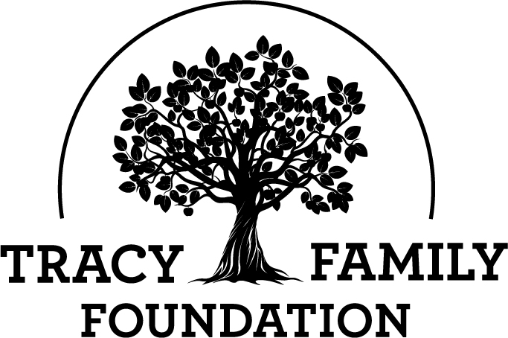

Next Generation Advisory Board

Meeting Minutes

Minutes: | November 21, 2022 |  | location: Zoom
6-7 PM CST

ATTENDEES | Kelsey Cope (Chair), Alex Tracy (Secretary), Kelsey Tracy, Megan Costigan (TFF Advisor)
MINUTES | Alex Tracy

GUEST SPEAKERS
ABSENT | Kendra Stamerjohn, Ari Buckley (Vice-Chair)

Welcome |  |  |  | Kelsey Cope
Discussion | Kelsey welcomed everyone.

Conclusions
Action items |  |  |  |  | Person responsible |  | Deadline

Special impact grant (SIG) |  |  |  | Kelsey Cope

Discussion
All four organizations submitted their Formal Grant Application. The TFF Staff reviewed each application and recommended full funding to the TFF Board. The Board will make the final funding decision at their December 2, 2022 board meeting.

Organization Name | Organization Address | Program/Project Name | Request Amount
Operation Food Search | St. Louis, MO | Operation Backpack: Weekend Nutrition for Youth | $35,000
Boys and Girls Clubs of Tampa Bay | Tampa, FL | Food, Nutrition, and Farmer's Market Fun | $30,000
Gardeneers | Chicago, IL | Growing Equitable Food + Justice | $25,000
Smart Bellies | Breckenridge, CO | Kids Weekend Food and Family Bag Programs | $13,830

Conclusions
Action items |  |  |  |  | Person responsible |  | Deadline

Grant Application Review |  |  |  | Megan costigan
Discussion | Grant Application Review, Cycle 3 2022
Organization | Project/Program | Request Amount
Girl Scouts of Central Illinois | Leadership Experience – West Central IL | $10,000
North Greene Educational Foundation | Vocational Expansion | $10,000
YWCA of Quincy | Permanent Supportive Housing Utilities | $4,000

Our Goals (Review, Discussion & Recommendation)
Questions to consider:
- Has the organization clearly communicated their request?
- Does the organization have experience and capacity to conduct the program?
- Will grant positively impact TFF Focus Areas?
- Are there “red flags” in the Budget that cause concern?
- Is sustainability of this project or organization a concern?
- Does the organization have measurable outcomes defined?

Conclusions |  | - Girl Scouts of Central Illinois – voted full funding  - North Greene Educational Foundation – voted full funding  - YWCA of Quincy – voted full funding
Action items |  |  |  |  | Person responsible |  | Deadline

3g special impact team |  |  |  | Megan Costigan
Discussion | Megan provided an overview of the draft proposal for the 3G Special Impact Team. The 3G Special Impact Team would be similar to the current NGAB Special Impact Grant, but with a handful of changes. The main purpose for this change is that the pool of eligible and interested 3Gs is very minimal. The 4Gs won’t be old enough to serve on NGAB for another couple years. The 3G Special Impact Team also provides 3Gs with a different engagement opportunity. All NGAB members voiced that they liked the overall plan. No questions and no suggestions for a different name at this time. NGAB members do feel confident that we should have NGAB as it is, with some changes, when 4Gs are old enough.

Conclusions
Action items |  |  |  |  | Person responsible |  | Deadline
Propose 3G Special Impact Team to TFF Board at December 2022 Board meeting |  |  |  |  | Megan |  | 12/2/2022
3g/4g family grant participation |  |  |  | Megan Costigan

Discussion
 | Participation as of 5/24/2022 | Participation as of 7/13/2022 | Participation as of 8/15/2022 | Participation as of  11/4/2022
3G Next Gen | 16% | 20% | 25% | 45%
3G Matching | 31% | 35% | 40% | 42%
3G Invitation | 19% | 38% | 87.8%
4G Next Gen | 16% | 55% | 55% | 66%
2G Matching | 50% | 75% | 75%
2G Invite | 31% | 43% | 100%
Volunteer Incentive | 0% | 0% | 0%

Conclusions
Action items |  |  |  |  | Person responsible |  | Deadline

Ajourne |  |  | kelsey Cope

Discussion
Kelsey and Megan thanked NGAB members for their service on NGAB this year. Kelsey also confirmed this is the last meeting for the year.

Megan asked NGAB members to keep an eye out for an end-of-year feedback survey.

Conclusions
Action items |  |  |  | Person responsible | Deadline

