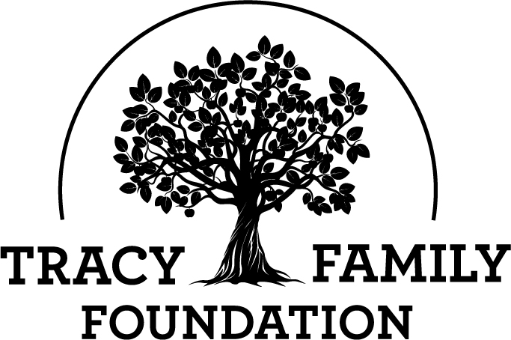

Next Generation Advisory Board

Meeting Minutes

Minutes: | August 16, 2022 |  | location: Zoom
6-7 PM CST

ATTENDEES | Kelsey Cope (Chair), Ari Buckley (Vice-Chair), Alex Tracy (Secretary), Kelsey Tracy, Kendra Stamerjohn, Megan Costigan (TFF Advisor)
MINUTES | Alex Tracy

GUEST SPEAKERS

Welcome |  |  |  | Kelsey Cope
Discussion | Kelsey welcomed everyone to the meeting.

Conclusions
Action items |  |  |  |  | Person responsible |  | Deadline

Special impact grant (SIG) |  |  |  | Kelsey Cope
Discussion | Kelsey opened it up for discussion and asked if anyone had questions about any of the organizations. Alex shared a little more about Smart Bellies and ultimately he does recommend inviting them to apply for funding based on his conversations and site visit at the organization. Kelsey C talked a little about Gardeneers and she recommended inviting them to apply as well. There were no questions about the other three organizations.
Organization Name | Organization Address | NGAB Member | # of NGAB
 |  | Assigned to Research | Members Who Voted to Invite
Healthy Schools Campaign |  | Kendra Stamerjohn | 2/5
 | CHICAGO, IL
Operation Food Search |  | Ari Buckley | 5/5
 | St. Louis, MO
Boys and Girls Clubs of Tampa Bay |  | Kelsey Tracy | 5/5
 | TAMPA, FL
Gardeneers |  | Kelsey Cope | 4/5
 | CHICAGO, IL
Smart Bellies | BRECKENRIDGE, CO | Alex Tracy | 4/5

Conclusions
Action items |  |  |  |  | Person responsible |  | Deadline
Megan will send out email tomorrow for final votes. |  |  |  |  | All NGAB Members |  | 8/24

next gen ozark meeting |  |  |  | Kelsey Cope
Discussion | Kelsey asked for feedback about this year’s Next Gen Ozark Meeting. Most of the group had already emailed Megan feedback, but in addition they shared a consensus that the changes worked really well. The two big changes were that no 4Gs ages 0-4 were invited to attend and only 3G and 4Gs ages 5 and older were encouraged to attend. We also updated the grant discussion and voting so this took place in smaller groups. A few suggestions for next year were:  - Provide an update on the organizations who received the additional $3,000 grants the previous year. What did they do with that money?  - Display the ‘final’ organization names on the projector during the grant voting  - Review small table assignments the night before meeting to ensure it makes sense based on attendance changes

Conclusions
Action items |  |  |  |  | Person responsible |  | Deadline

3G/4G Family grant participation |  |  |  | Megan Costigan

Discussion
 | Participation as of 5/24/2022 | Participation as of 7/13/2022 | Participation as od 8/15/2022
3G Next Gen | 16% | 20% | 25%
3G Matching | 31% | 35% | 40%
3G Invitation | 19% | 38% | 87.8%
4G Next Gen | 16% | 55% | 55%
2G Matching | 50% | 75% | 75%
2G Invite | 31% | 43% | 100%
Volunteer Incentive | 0% | 0% | 0%

- Megan encouraged NGAB members to continue reminding the cousins their assigned to this year.
- Megan asked for ideas on how to get more people to participate in the family grant programs they’re eligible for… everyone agrees that texts and emails both work well. Megan will send individual communication reminders in September.
- How do we encourage family members who rarely/never participate?
- On social media, share examples of where others have given (e.g. family member spotlights)

Conclusions
Action items |  |  |  |  | Person responsible |  | Deadline

Ajourne |  |  |  | kelsey Cope

Discussion
Next meeting is September 22, 2022.

Conclusions
Action items |  |  |  |  | Person responsible |  | Deadline

