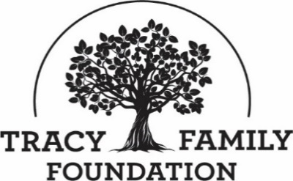

Tracy Family Foundation Board Meeting Minutes

DATE: | December 2, 2022
TIME: | 8:30 a.m. – 3:45 p.m., then Executive Session
LOCATION: | Dot Foods: Mt. Sterling, IL
TRUSTEE ATTENDEES: | Jean Buckley, Susie Stamerjohn, Wanda Tracy, Ben Tracy (via Zoom), Kristin Tracy, Linda Tracy, Kenzie Tracy (via Zoom), Mark Yingling, Sam Sullivan, Tim Curtin
PARTIAL PORTION OF MEETING (FOR DOT CHARITABLE REPORT): | Suzy Parn
TFF STAFF ATTENDEES: | Dan Teefey, Terry Jenkins, Megan Costigan, Angie Schlater, Kim Bielik

WELCOME & OPENING PRAYER: JEAN & SAM
Discussion | Jean welcomed everyone to the meeting. Wanda opened the meeting with a prayer.

CONCLUSIONS
Action items |  | Person responsible | Deadline
Assign someone to open the December board meeting with a prayer. |  | Jean | 12/13/22

ABOUT ROBERT & DOROTHY TRACY: SAM
Discussion | Sam shared a story about when he was younger. He was a tad hyperactive, and he enjoyed jumping around and climbing on everyone. One time Grandma Tracy said, “You know Sam, you’re one weird little kid!” But it didn’t matter, because any connection you had with Grandma Tracy mattered and meant a lot!

CONCLUSIONS
Action items |  | Person responsible | Deadline

APPROVE MINUTES: JEAN
Discussion | Jean asked for a motion to approve the 7/27/2022 board minutes.
CONCLUSIONS | Wanda made a motion to approve the 7/27/2022 board minutes. Linda seconded the motion, and all were in favor.
Action items |  | Person responsible | Deadline
Secure DocuSign signatures |  | Jean | 2/15/2023

TFF TRUSTEES: JEAN
Discussion | TRUSTEES  - Terms Expiring on 12/31/22: Kenzie Tracy, Sam Sullivan, Wanda Tracy  - 2023 Trustees: Ben Tracy, Eric Terwelp, Jean Buckley, Jim Tracy, Kelsey Tracy, Kristin Tracy, Linda Tracy, Mark Yingling, Susan Stamerjohn, Tim Curtin.  2023 SLATE OF OFFICERS - RECOMMENDATION: President – Jean Buckley / Vice-President – Susan Stamerjohn / Secretary – Ben Tracy / Treasurer – Kristin Tracy.  SUSIE STAMERJOHN’S ROLE: Susie will begin working with Dan and Jean in 2023 to learn the ropes for her role as TFF Board Chair which begins in January 2024. Jean will remain on the board through 2024.
CONCLUSIONS | Jean asked for a motion to approve the 2023 Slate of Officers recommendation. Linda made a motion to approve the 2023 TFF Slate of Officers. Mark seconded the motion, and all were in favor.
Action items |  | Person responsible | Deadline

FINANCIALS: DAN & KRISTIN
DISCUSSION | FINANCIAL REPORT: KRISTIN  Kristin presented the year-to-date financial report as of October 31, 2022.  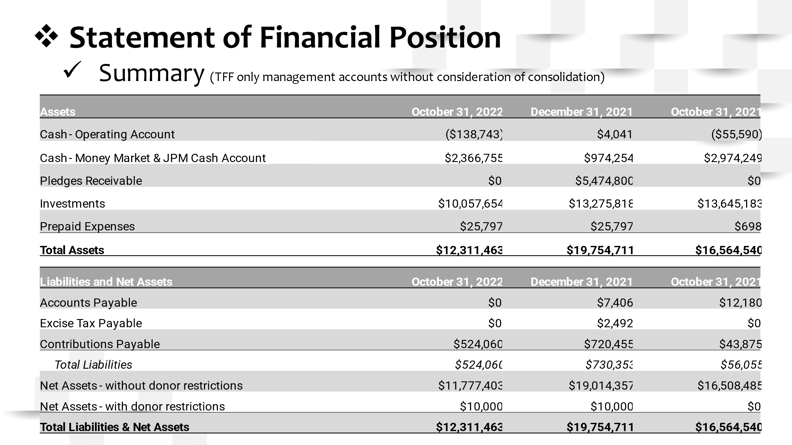  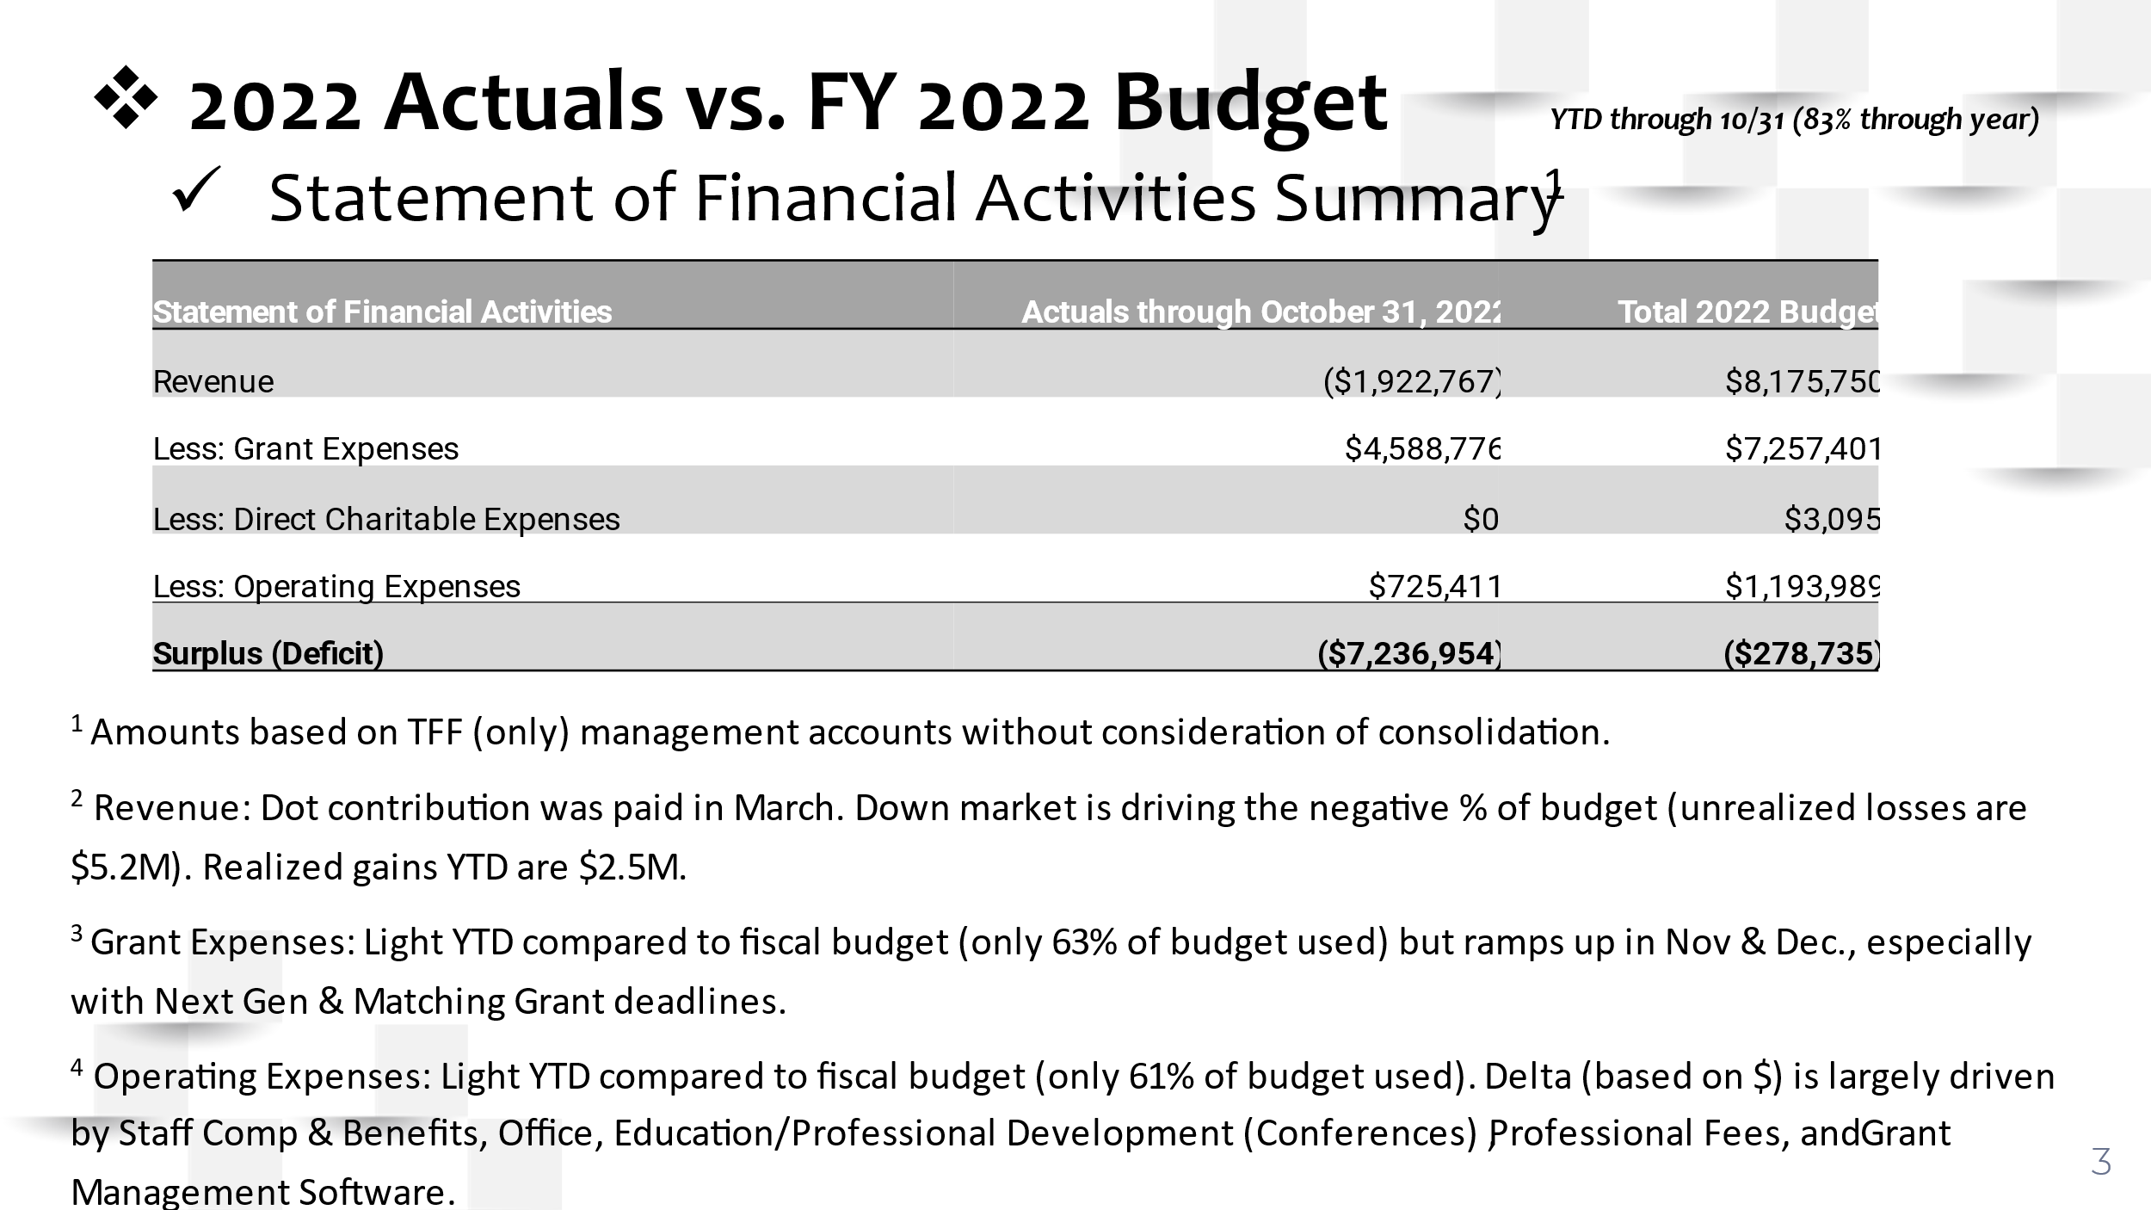  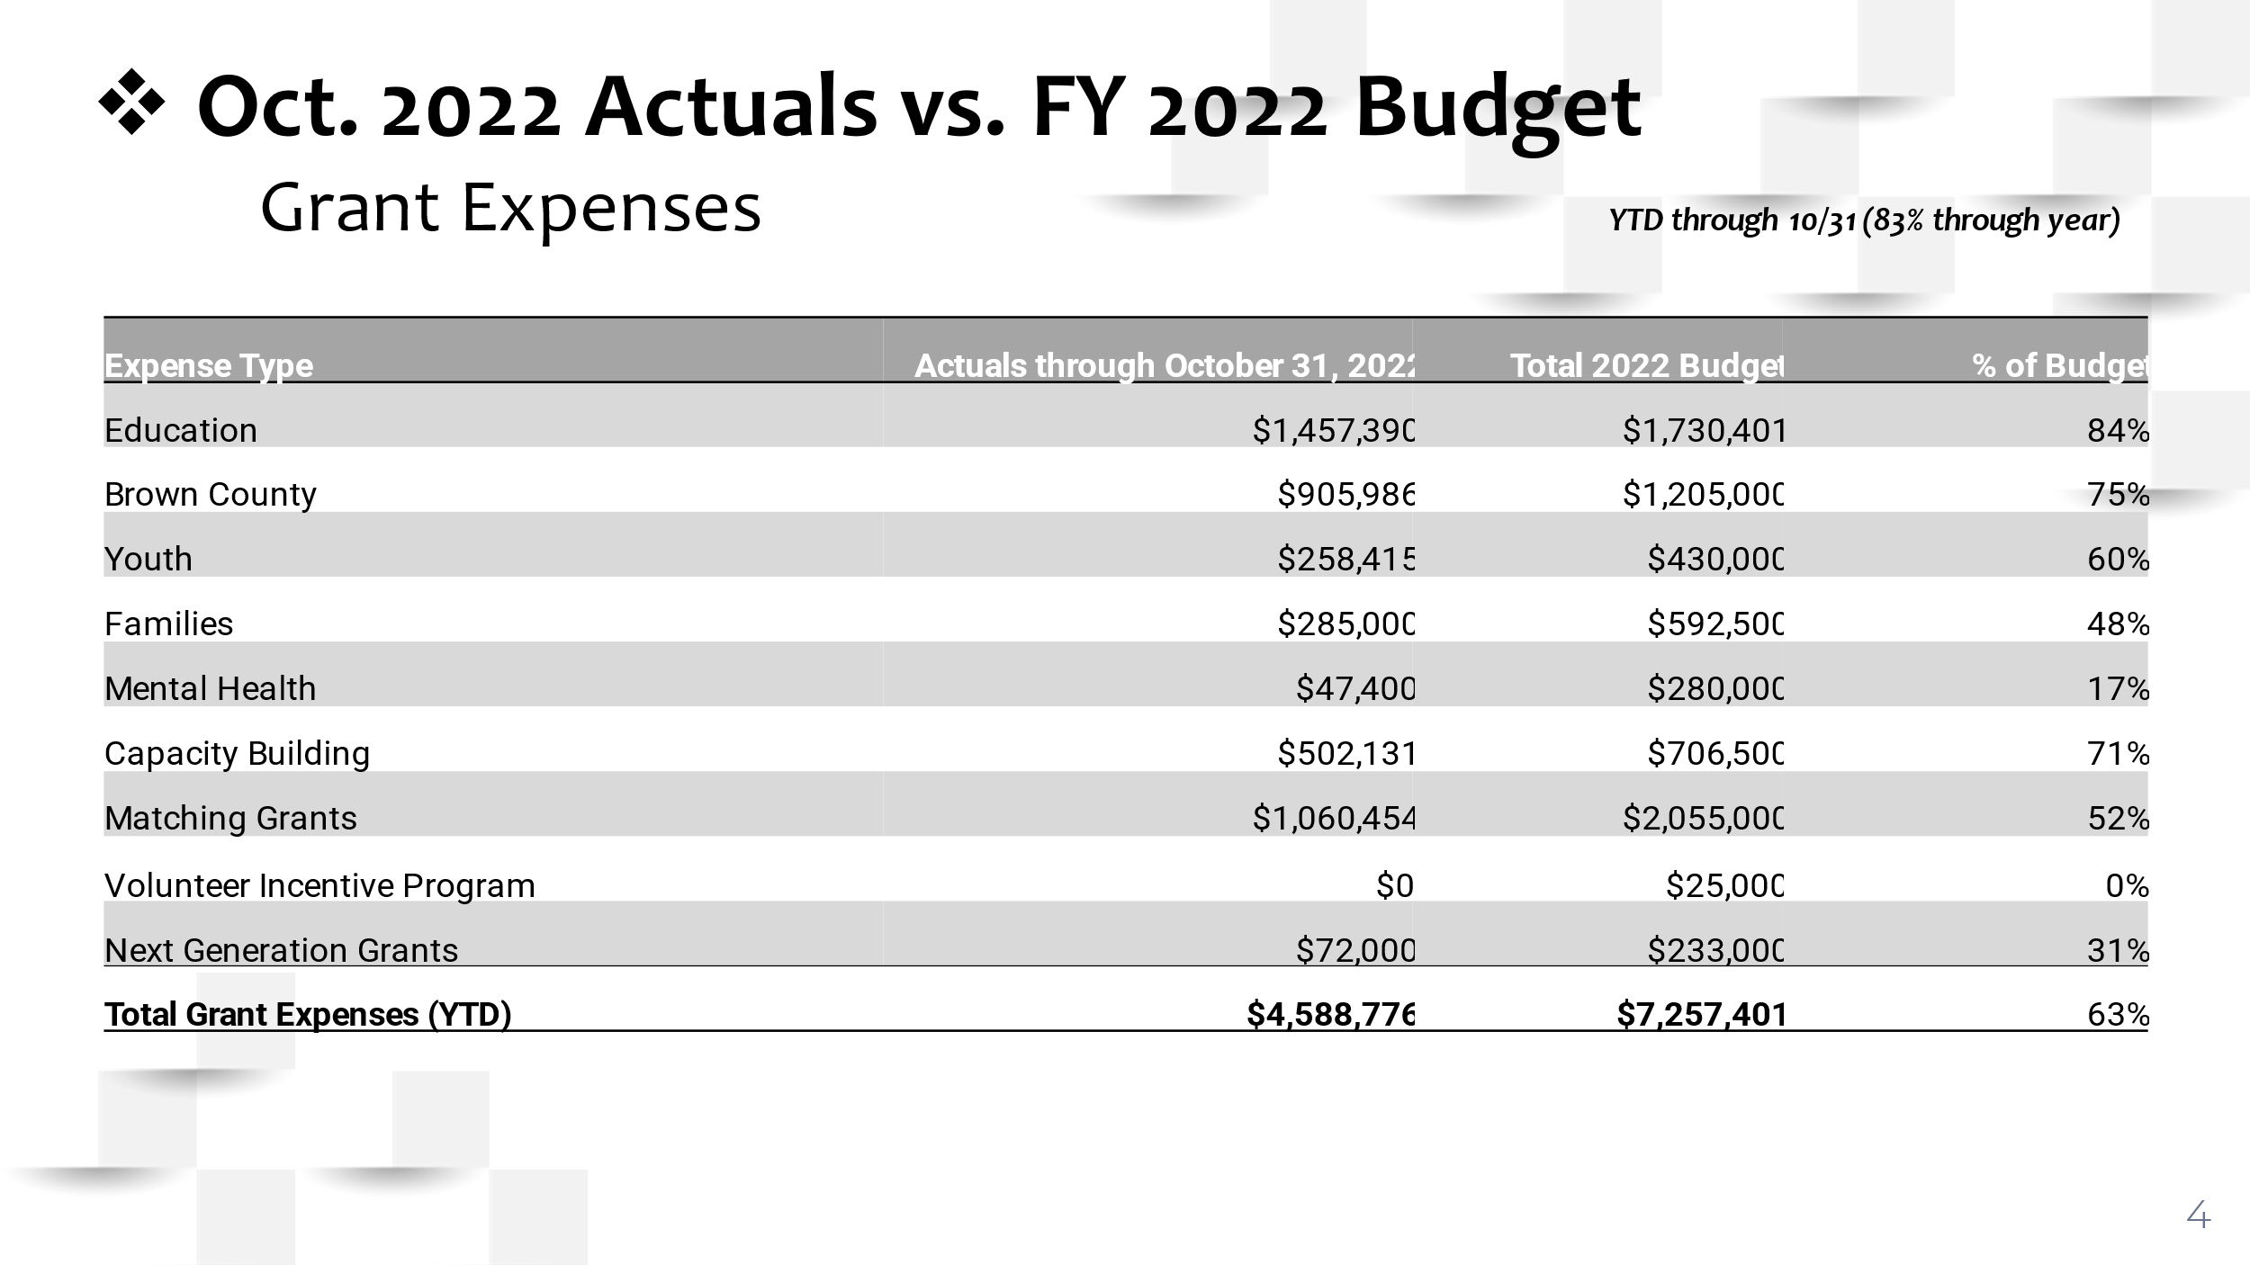  INVESTMENT AND CASH BALANCE: DAN  Dan reviewed the TFF End of Year Investment and Cash Balance Guideline with the board which states: the Foundation should seek to finish the year with a minimum investment and cash balance that exceeds the greater of the following amounts: 1) Average of the prior 2 years total expenditures or 2) Incoming year’s budgeted expenditures. The Foundation should seek to finish the year with an investment and cash balance that does not exceed twice the minimum balance.  The red line in the graph below represents the minimum investment and cash balance to maintain and the green line represents the maximum investment and cash balance to maintain. We are in compliance with the Guideline at this point, but this calculation is based upon an estimate of our end-of-year balances, which are subject to market volatility  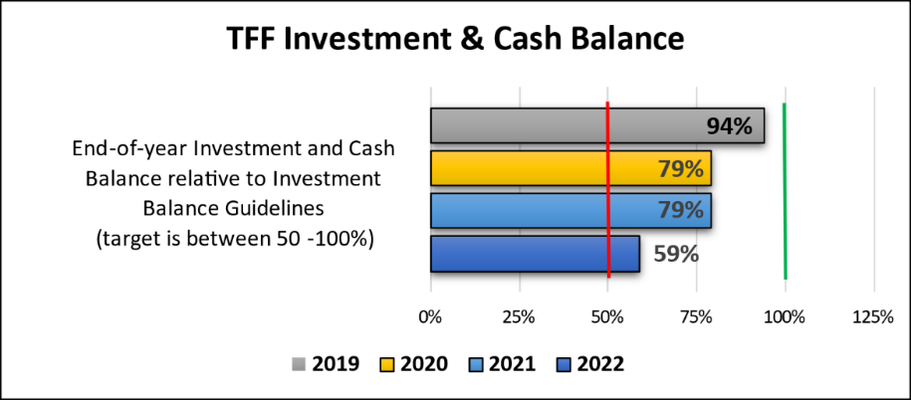  2023 BUDGET PROCESS: DAN  Dan is compiling financial projections for the 2023 budget. On the Dec. 19, 2022 board call, Dan will present a draft of the 2023 budget and ask for approval. Dan will present and ask for final approval of the 2023 budget at the first 2023 board meeting.  INVESTMENT REPORT: DAN  Dan shared the investment report (through October 2022) from JP Morgan. He reviewed the asset allocations and shared that the portfolio has been reallocated based on our new TFF Investment Policy and JP Morgan’s recommendations, which were approved by the TFF board.

CONCLUSIONS
Action items |  | Person responsible | Deadline

TFF FINANCE MANAGER: DAN
Discussion | We posted the job description for the second time in June. We had 19 applicants and pursued 3. We offered the position to Robyn Pilliod, and she accepted. Robyn was the former Director of Institutional Advancement at Chaminade College Preparatory School. She is a CPA, licensed in Missouri, and has 20 years of audit and management experience. Robyn lives in St. Louis and will travel to Mt. Sterling as needed. The plan is for Robyn to start the week of January 9th. She will work 20-30 hours per week and be paid on an hourly basis.

Conclusion
Action items |  | Person responsible | Deadline

DOT ANNUAL CONTRIBUTION TO TFF: JEAN
Discussion | Dot has provided 3% of pre-tax profits to TFF every year since 2001. The family has not discussed increasing the percent since the 2011 TFF Retreat. This topic will be explored for the next several months before a proposal is presented to the Dot Foods board, TFF board, and Tracy family. A committee has been assembled to explore this topic: Jean (Chair), Brian Buckley, Christine Iovaldi, Fred Schmidt, and Mary Sullivan (with Pat Tracy assisting as needed). A proposal will be presented to the family at the 2023 AFM.  Feedback:  - General Feedback: The board approves of the process and the content that will be provided in order for all key stakeholders to have an informed opinion on an increase.  - Why increase? TFF does a good job with the money we are given. We have a good infrastructure, we give the money in a thoughtful, purposeful manner.  - Concerns: Does TFF have the staff capacity to handle an increase? Would making more dollars to nonprofits increase the dependence of some nonprofits on TFF? Would more grant dollars going into west central IL increase the spotlight on Tracy wealth?  - Suggestions: TFF needs to prioritize some of the big projects being considered before taking a proposal to the family. Jean needs to talk to John, Joe, and Dick to see if they have a % in mind for an increase.
Conclusion | Regardless of the decision that will be made, the education that this process will provide to the family is very valuable.
Action items |  | Person responsible | Deadline
Meet with John, Joe, and Dick. |  | Jean | 1/10/23
Work with staff & board to prioritize big project list. |  | Jean | 1/30/23

% OF GRANT DOLLARS TO BUDGET: JEAN & DAN
Discussion | % OF GRANT DOLLARS TO BUDGET – PROGRAM: JEAN  TFF has never had a firm policy on % of dollars to budget for Focus Areas vs. Capacity Building vs. Matching/Next Gen grant program. Should we? Jean reviewed the 1998 – 2021 history of % of grant dollars awarded in these programs.  The National Forum on Family Philanthropy (NCFP) recently released a report on managing complexity in family philanthropy. The report shares how families can best work together in their philanthropy over generations. One of their findings was that collaborative family philanthropy contributes to stronger family relationships compared to individualized philanthropy. They also found that individualization in the family foundation has a limited life span.  At the February 2023 board meeting, we will review the LGA/NCFP research more thoroughly before making a decision about guidelines for budgeting dollars to the various grant programs. For the 2023 budget, we will likely stick to the $60K/person allowance for the Matching Grant program. Trustees offered a lot of positive feedback on the importance of the Matching Grant program to family members.  % OF GRANT DOLLARS TO BUDGET – GEOGRAPHY (INSIDE & OUTSIDE of West Central Illinois): DAN  TFF has never had a firm policy on the % of dollars to budget for West Central Illinois vs the USA. Should we? Dan shared 1999 – 2021 data on dollars spent inside vs. outside WCI. Over the last 5 years, the range has been 37% - 39% spent outside of west central IL and 61% - 63% inside west central IL. Outside of WC IL is driven by Tracy family grant programs (matching, next generation, and invitation grant programs). When family members were asked at the TFF retreat what percentage should stay in WCI, the range (with the exception of one outlier) was 50% - 75%.  % OF GRANT DOLLARS TO BUDGET – GEOGRAPHY (BC INSIDE WCI): DAN  TFF has never had a firm policy on the % of TFF’s support of West Central Illinois that should go to Brown County only. Should we? Dan shared 1998 – 2021 data on dollars granted for BC activities. When family members were asked at the TFF retreat what percentage should stay in Brown County, the range (with the exception of two outliers) was 40% - 60%.
Conclusion | There were no conclusions made on guidelines at the point.
Action items |  | Person responsible | Deadline
% of Grant Dollars to Budget by Program: 1) Research the average size of discretionary funding at other family foundations 2) Do the math. What does the giving look like in terms of % and $ for the next 25 years? Look at it as program is currently structured. Also run the numbers if $ allowance was changed based on age. |  | Jean | 1/20/23
Work towards reaching a conclusion on budget guidelines for TFF grant programs, Brown County, and west central IL. |  | Dan & Jean | 9/1/23

GRANT APPLICATION REVIEW & FUNDING DECISIONS: DAN & TERRY
Discussion | Jean reminded everyone of the TFF Conflict of Interest Disclosure. The board then moved forward with making funding decisions. Dan reported on Grant Variance decisions, Staff Discretionary Grant decisions, and Invitation Grant approvals.
CONCLUSIONS | Funding decisions are noted below.  GRANT APPROVALS  - Communio: $55,000  - Empower Illinois: $50,000  - Regional Office of Education #1: $30,000  - West Central Child Care Connection: $51,480  - John Wood Community College: $47,518  - Saint Mary School: $25,000  - St. John the Evangelist: $30,000  - Beardstown CUSD 15: $9,845.73  - St. Francis Solanus School: $10,000  - Beardstown CUSD 15: $20,000  - Illinois 100 Club: $10,000  - Cheerful Home Child Care and Early Learning Center: $17,000  - National Catholic Education Association: $7,500  - Oak Rose Fund: $7,500  - Quincy Community Theatre: Up to $30,000 after follow-up  - Southeastern CUSD #337: $15,000  - Mindful Philanthropy: $54,000  - YMCA of West Central Illinois: Up to $7,500  - Boys and Girls Clubs of Tampa Bay: $30,000  - Gardeneers: $25,000  - Operation Food Search: $35,000  - Smart Bellies: $10,000  - Girl Scouts of Central Illinois: $10,000  - North Greene Educational Foundation: $10,000  - YWCA of Quincy: $4,000  CHALLENGE GRANTS  - None  SITE VISITS  - Quincy Art Center  - Quincy Public Library | SV, then authorize Dan to approve up to $50,000 with the potential for a Challenge Grant.  - The Salvation Army of Quincy | SV, then authorize Dan to approve up to $10,000  - Bella Ease  - Quincy Public Schools | SV, then authorize Dan to approve up to $27,198  - Rooney Elementary School | SV, then authorize Dan to approve up to $39,300  - Girls on the Run of Central Illinois | SV, then authorize Dan to approve up to $12,000  - Our Saviour of St. Vincent De Paul | SV, then authorize Dan to approve up to $10,000  - LUME Institute, LLC | SV, then authorize Dan to approve up to $33,500  DENIED FUNDING  - None  REPORT ON INVITATION GRANTS  - Ronald McDonald House Charities – St. Louis, MO: $30,000  - The Rise School of Denver – Denver, CO: $45,000  - Boys and Girls Club of Central Illinois – Springfield, IL: $15,000  - Part of the Solution – Bronx, NY: $15,000  - Boys Hope Girls Hope – St. Louis, MO: $15,000  - AeroAngel – Denver, CO: $15,000  - Clayton Early Childhood Center – Clayton, MO: $15,000  - Feeding Westchester – Elmsford, NY: $15,000  - The Los Angeles Free Clinic – Los Angeles, CA: $15,000  - St. Patrick Catholic School – Springfield, IL: $15,000  - St. Peter Catholic Church – St. Louis, MO: $30,000  - Camp Wojtyla – Denver, CO: $30,000  - A Precious Child – Denver, CO: $30,000  - St. Louis Roman Catholic Theological Seminary – St. Louis, MO: $30,000  - Child Advocacy Center, Inc. – Fayetteville, NC: $15,000  - Children’s Home Society of Missouri dba FamilyForward – St. Louis, MO: $15,000  - Summit County Senior Citizens – Denver, CO: $15,000  - Good Shepherd Family & Children – St. Louis, MO: $15,000  REPORT ON GRANT VARIANCES  - Iles Elementary School: $2,189.30 – Approved  - Our Saviour School: $30,000 – Approved  - Quincy Children’s Museum: $2,988.88 – Approved  - Western Illinois Youth Camp: $1,828.12 - Approved

CONCLUSION
Action items |  | Person responsible | Deadline
Process grants |  | Kim and Dan | 12/15/2022
Schedule Site Visits |  | Dan | 3/15/23

GRANTEE HIGHLIGHT – OPEN PARACHUTE: ANGIE
Discussion | Open Parachute is a mental health and well-being program created for K-12 schools. Schools piloting the program in school year 2022-23 are: Western School District, Pikeland School District, Brown County School District, Winchester School District, Virginia School District, and St. Paul Catholic School. The schools were trained on the program in October. Overall, Angie has heard nothing but positive things about this program so far.

CONCLUSIONS
Action items |  | Person responsible | Deadline

NGAB UPDATE: MEGAN
Discussion | NGAB was founded in January 2013. 28 of the 66 3Gs have served. Of the 3Gs that are eligible and have not served, very few are interested in serving. Many 3Gs now view NGAB as the “kiddie table”. NGAB will pause in 2023 with plans to start back up in 2024 and be geared towards 4Gs that are ages 10 years and older.  As a strategy to engage interested 3Gs in a new manner, Megan proposed that TFF launch a 3G Special Impact Team. All 3Gs would be welcome to be a part of it. It would be a one-year commitment. She presented the following questions to the board:  - Question: Should we require eligible organizations to be located within 45 miles of community where a Tracy family member serving on the 3G Special Impact Team currently lives? Feedback: Yes  - Question: Should we allow organizations in West Central Illinois to be eligible? Feedback: Yes.  - Question: Should TFF Staff or 3Gs select the focus area each year? Feedback: Staff, but make sure it is a focus area of interest to 3Gs.  - Question: Dollars can be given to up to two organizations. Is this the right number? Feedback: Former NGAB member really liked the idea of the process being streamlined to two organizations.  - Question: A site visit is required with at least two family members. Preference for one TFF staff member to attend. Feedback: ?  - Question: Is $150,000 the right budget? Feedback: Even $100,000 would be great.  It was also suggested that TFF consider a name other than Special Impact Team (SIT) as it sounds too much like Special Impact Grant (SIG). The name Opportunity Fund was suggested.

CONCLUSIONS
Action items |  | Person responsible | Deadline
Draft a formal proposal for the board. |  | Megan | 1/20/23

BROWN COUNTY: ANGIE & DAN
Discussion | DOROTHY TRACY ESTATE GIFT: DAN  Dan outlined the details of the Dorothy Tracy Estate Gift. He provided an update on the following projects that have been approved or are being considered for funding: Holy Family/St. Mary, Pool, Trails, Library. Dorothy’s estate gift to TFF was $1,854,426. There is a remaining balance of $1,422,858.  BC TRAILS: DAN  Dan reviewed the Trails plan. There are multiple phases for this project. TFF just helped the County complete a $2.7M IL Transportation Enhancement Program grant application for a portion of the trails. We find out in Spring 2023 if the county will receive this grant.  We included $250k in the 2022 budget for construction of the loop at Clark Park. The hope is to begin construction on the Clark Park Loop in the spring 2023. The estimate from Farnsworth to complete the Clark Park Loop Trail was $210,116. Using local resources, our cost range was $125,440 - $172,800. A recommendation was presented to the board to approve a grant of up to $250,000 for the construction of the Clark Park loop trail.  The board then discussed whether we would want to name this trail the Dorothy Tracy Memorial Trail. Mark shared that the community members he has talked to would be very supportive of naming it after Dorothy. Linda suggested that we think about the most appropriate project(s) to put Dorothy’s name on as it is questionable if she would want her name plastered on numerous projects.  BC EARLY LEARNING CENTER & DTEC UPDATE: DAN & ANGIE  The BCELC rates for every age group will be raised in 2023 by $10 per week. November enrollment is at 58, which is the highest we’ve ever had. Dan shared items the center is working on now.  TFF is the sole member of both DTEC and BCELC. As the sole member, TFF is responsible for appointing board members for each entity. The recommended 2023 slate of directors is as follows:  DTEC Directors Recommendation: Jean Buckley, Jim Tracy, Dan Teefey  BCELC Directors Recommendation: Jean Buckley, Jim Tracy, Dan Teefey  MT. STERLING UPTOWN 2023 STRATEGIC PLAN: DAN  In 2011 TFF funded the creation of a Mt. Sterling Uptown Strategic Plan. Many of the priorities in that plan have now been completed. The staff believes it is time to consider developing a new Uptown Strategic Plan. The intent is to put dollars in the 2023 budget to develop an updated Plan.  BC 2022 SURVEY RESULTS: DAN  The Brown County Survey for 2022 will be finished in early 2023. We’ll have a public meeting where our consultant will walk the community through the results. Dan shared some highlights of the survey.
CONCLUSIONS | Wanda made a motion to allow Dan to approve a grant of up to $250,000 for the construction of the Clark Park Loop Trail. Susie seconded the motion, and all were in favor. (Mark did not vote due to a conflict of interest because he’s on the county board).
 | Mark made a motion to approve the 2023 DTEC and BCELC Directors. Ben seconded the motion, and all were in favor.
Action items |  | Person responsible | Deadline

TRACY FAMILY EDUCATION PLATFORM: MEGAN
Discussion | In a joint effort, the Family Council and the TFF are working on the development of a Tracy family education curriculum. It will be called the Tracy Learning Center (TLC). Committee members working on the TLC are Jean, Dan, Erin Bird, and Megan. The curriculum is being broking out into 4 Learning Pathways:  - Our Family (relationships, communication, dynamics, branding, etc.)  - Our Family Businesses (DFH businesses, ownership, leadership opportunities w/in the business, etc.)  - Our Family Philanthropy  - Our Family Finances (financial literacy, budgeting, estate planning, etc.)  Megan shared decisions to date as well as decisions that need to be finalized.  One of the first projects that will kick-off the TLC is the TFF Next Gen Milestone project. Starting in January 2023, Next Gen family members will receive a birthday card on their birthday (ages 1-18), as well as a gift at milestone birthdays. The intent of this program is three-fold: 1) to develop the philanthropic spirit in 3G and 4G Tracy family members and 2) to build awareness of TFF at an early age and 3) to educate 3Gs and 4Gs on TFF engagement opportunities.

CONCLUSIONS
Action items |  | Person responsible | Deadline

DOT CHARITABLE REPORT: SUZY PARN
Discussion | Suzy provided an overview of Dot Charitable, including areas of intent, leadership structure, programs, and what they do with food. She also provided a look into 2023.

CONCLUSIONS
Action items |  | Person responsible | Deadline

TFF OFFICE: DAN
Discussion | TFF’s office is now operating out of Dot Foods’ main office. There is increased interest in the family for TFF to secure a permanent office somewhere in Uptown Mt. Sterling.  As a follow-up to the July meeting, Dan had an architectural firm come look at one building that is being considered. It would be about $450,000 to do a full rehab. In addition, it would probably cost $50,000 to buy the building. And, if TFF continues to scale up, we likely wouldn’t have the space to stay in this building long-term. The board discussed that TFF could knock that or any other building down and build a great space for not significantly more money. That way TFF would get what we want and even potentially be able add on later if capacity increases.  The board also discussed TFF moving into the Dot Marketing offices above Hagel while a TFF office is being built or renovated. The board brainstormed locations in the Mt. Sterling Uptown area that should be explored for a permanent TFF office.
CONCLUSIONS | Secure office space in Uptown Mt. Sterling that is permanent and that will work for future growth of the foundation. We should even consider tearing down a building Uptown that is an eyesore and building a new building in that location.
Action items |  | Person responsible | Deadline
Compile an updated list of buildings & locations that might be available for a TFF office. |  | Dan | 1/30/22

FOCUS AREA UPDATES/Q&A: DAN
Discussion | Dan did a call for questions/comments regarding the updates provided on Focus Areas, Capacity Building, and NGAB.

CONCLUSIONS
Action items |  | Person responsible | Deadline

25TH ANNIVERSARY RETREAT: DAN
Discussion | Survey results from the 25th Anniversary TFF retreat indicated that the family enjoyed the information/presentations/testimonies/learning about specific projects. However, they felt they received too much info at once. Suggestions included going at a slower pace and having more discussion/engagement around questions at the tables. It was also suggested that TFF bring in an outside presenter on a topic that is relative to the foundation and family that requires thoughtful conversations and discussion. The survey showed people prefer to have the retreat every 2-3 years.
CONCLUSIONS | The board agreed with the feedback provided in the survey results.
Action items |  | Person responsible | Deadline

GUIDELINE UPDATES: DAN
Discussion | Dan shared recommended changes to the Capacity Building and Youth Trip Guidelines.  Summary of Recommended Capacity Guideline Changes  - Limited organizations outside of West Central IL to participation up to 5 years after receiving a Formal Funding grant.  - Added the requirement that all applicant organizations complete the TFF Nonprofit Roadmap Assessment at least every 12 months.  - Clarified the language on “selected projects” and “TFF RFPs”.  Summary of Recommended Youth Guideline Changes  - Expanded the youth age to 22 (from 18) to capture college students.  - Added clarity to the program funding.
CONCLUSIONS | Linda made a motion to approve the changes to the Capacity Building Guidelines. Tim seconded the motion, and all were in favor.  Wanda made a motion to approve the changes to the Youth Trip Guidelines. Sam seconded the motion, and all were in favor.
Action items |  | Person responsible | Deadline
Make approved changes to Guidelines |  | Jean | 12/31/22
Upload revised policies to the TFF website. |  | Kim | 01/10/2023

TRACY FAMILY PHILANTHROPIC PLATFORM: JEAN
Discussion | Jean provided an update on the Tracy Family Philanthropic Platform as well as next steps. At the next TFF board meeting, we will discuss the pros/cons of different models that multi-generational families in the US are using when collaborating on their family philanthropy. In 2023, we may issue a RFP to several firms for the purpose of recommending and designing a platform framework for Tracy family philanthropy.  It was also shared that Dan and Jean met with Foundation Source, the nation’s largest provider of management solutions for private foundations. They are the “back office” for a lot of family foundations. Foundation Source has over 2,000 private family foundation clients and a 98% client retention rate. Jean shared the different services Foundation Source offers. We will continue to keep Foundation Source as a potential vendor for services.

CONCLUSIONS
Action items |  | Person responsible | Deadline

2022 DASHBOARD: DAN
Discussion | Dan reviewed the Key Performance Indicators on the Dashboard provided to the board. There was then a call for questions and suggestions.
CONCLUSIONS | The Dashboard is appreciated by the board.
Action items |  | Person responsible | Deadline

NEXT MEETING DATES: JEAN
Discussion | BOARD MEETING DATES:  Dec. 19| Board Mtg (Zoom): 11:30 – 1:00

CONCLUSIONS
Action items |  | Person responsible | Deadline

2022 TRUSTEE FAREWELLS: JEAN
Discussion | Everyone said their goodbyes to Kenzie, Sam, and Wanda. They were thanked for their dedication and hard work. Jean presented Sam with a special plaque. Plaques are due to Kenzie and Wanda.
CONCLUSIONS | Kenzie, Sam, and Wanda will be missed!
Action items |  | Person responsible | Deadline
Send Wanda & Kenzie their ABCs of Life plaques. |  | Jean | 8/15/22

ADJOURN: JEAN
Discussion | Ben made a motion to adjourn the meeting at 3:45 p.m. Kristin seconded the motion, and all were in favor.

CONCLUSIONS
Action items |  | Person responsible | Deadline

AN EXECUTIVE SESSION WAS HELD IMMEDIATELY FOLLOWING THE BOARD MEETING. THERE ARE SEPARATE MINUTES FOR THE EXECUTIVE SESSION.

SUBMITTED BY (TFF ADMIN): | Kim Bielik
APPROVED BY (TFF SECRETARY):

APPROVED BY (TFF PRESIDENT):

