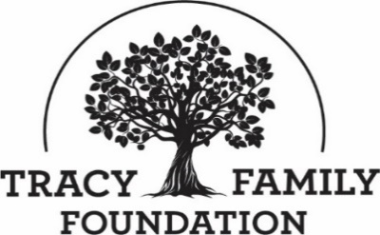

Tracy Family Foundation Board Meeting Minutes

DATE: | April 12-13, 2022
TIME: | April 12: 10:00 a.m. – 4:45 p.m.  April 13: 8:00 a.m. – 10:45 a.m., then Executive Session
LOCATION: | Dot Foods: Chesterfield, MO
TRUSTEE ATTENDEES: | Jean Buckley, Susie Stamerjohn, Wanda Tracy, Ben Tracy, Kristin Tracy, Linda Tracy, Kenzie Tracy, Mark Yingling, Sam Sullivan, Tim Curtin
MINUTES/STAFF ATTENDEE: | Kim Bielik
TFF STAFF ATTENDEE: | Dan Teefey, Angie Schlater, Megan Costigan, Terry Jenkins (Angie, Megan, and Terry present for day one only)

MEETING DAY ONE: APRIL 12, 2022

WELCOME & OPENING PRAYER: JEAN & SUSIE
Discussion | Jean welcomed everyone to the meeting. Susie opened the meeting with a prayer.

CONCLUSIONS
Action items |  | Person responsible | Deadline
Assign someone to open the July board meeting with a prayer. Send the prayer to the board & staff. |  | Susie | 07/01/2022

ABOUT ROBERT & DOROTHY TRACY: WANDA
Discussion | Wanda shared a story about Dorothy always staying positive and never complaining. Her faith always got her through. One of her favorite sayings was “This too shall pass”.

CONCLUSIONS
Action items |  | Person responsible | Deadline

APPROVE MINUTES: JEAN
Discussion | Jean asked for a motion to approve the 2/8/2022 board minutes.
CONCLUSIONS | Susie made a motion to approve the 2/8/2022 minutes. Wanda seconded the motion, and all were in favor.
Action items |  | Person responsible | Deadline
Secure DocuSign signatures. |  | Jean | 1/1/2023

2022 BOARD, STAFF, NGAB, & COMMITTEE MEMBERS: JEAN
Discussion | The 2022 roster of trustees, staff, NGAB members, and Advisory Committee members was shared to acknowledge the many individuals who give of their time and talent to support and accomplish the work of TFF.

CONCLUSIONS
Action items |  | Person responsible | Deadline
Populate the Compensation and Nominating Committees |  | Jean | 7/1/2022

TFF COMPASSES: DAN, JEAN, & STAFF
Discussion | Jean, Dan, and the staff shared details about the compasses that drive the work of the foundation, those being: 2019-28 Long Range Plan, 2020-24 Long Range Plan, and the 2022 staff goals.
CONCLUSIONS | A review of these compasses annually at the first in-person board meeting of the year is very helpful for the board.
Action items |  | Person responsible | Deadline
Send 2019-38 LRSP and status update information to trustees and staff. |  | Jean | 6/1/2022
Send 2019-38 LRP status update to family members and consider having a cover page with highlights. |  | Jean | 6/1/2022
Draft a list of projects that TFF would consider if a larger % of Dot pre-tax profit dollars were available to TFF. |  | Jean & Dan | 7/15/2022

GRANT DECISION-MAKING PROCESS: TERRY
Discussion | Terry reviewed the grant review process and the grant decision-making process with the board.

CONCLUSIONS
Action items |  | Person responsible | Deadline

GRANT APPLICATION REVIEW & FUNDING DECISIONS: DAN, TERRY, ANGIE, & JEAN
Discussion | Jean reminded everyone of the TFF Conflict of Interest Disclosure. The board then moved forward with making funding decisions. Dan reported on Grant Variance decisions, Staff Discretionary Grant decisions, and Invitation Grant approvals.
CONCLUSIONS | Funding decisions are noted below.  GRANT APPROVALS:  - Brown County Community Unit School District #1: $24,116  - Brown County Community Unit School District #1: $14,505  - Brown County Community Unit School District #1: $63,160  - Brown County Community Unit School District #1: $4,000  - Brown County Community Unit School District #1: $1,154  - Carrollton Public Library: $5,000  - Centenary United Methodist Church: $60,000  - City of Mt. Sterling: $75,000  - Colonel George Iles Elementary School: $25,000  - Community Foundation Serving West Central IL & Northeast MO: $12,000  - Community Foundation Serving West Central IL & Northeast MO: $30,000  - Community Unit School District #4 Mendon: Up to $30,001 (pending Site Visit)  - Covered Bottoms Diaper Bank: $15,000  - Fellowship of Christian Athletes: Up to $7,500 (pending final roster)  - Fellowship of Christian Athletes: $25,000 (plus $5000 Challenge Grant)  - Four Star Public Library District: $5,000  - Good Food Collaborative: $15,000  - Jacksonville Promise NFP: Up to $35,000 (pending Site Visit)  - National TTT Society IL Chapter AI: Up to $5,000 (pending Site Visit)  - Our Saviour School: $30,000  - Pittsfield Public Library: $5,000  - Quincy Catholic Elementary Schools Foundation: $25,000  - Quincy Notre Dame High School: $30,000  - Quincy Notre Dame High School: Up to $14,000 (pending final roster)  - Routt Catholic High School: Up to $30,000 (pending finalized marketing materials)  - Rushville Public Library: $5,000  - St. Alexius Church: Up to $12,000 (pending final actual cost and Final Report)  - St. Francis Solanus School: $30,000  - St. Francis/Holy Ghost School: Up to $30,000 (pending final curriculum decision)  - St. Paul School: $15,000  - St. Paul School: $15,000  - The HUB – Arts and Culturally Center: $20,000 (plus $5000 Challenge Grant)  - West Central Child Care Connection: $69,124  - White Hall Township Library: $10,000  CHALLENGE GRANT APPROVALS:  - Fellowship of Christian Athletes: $5,000 (1:1, new donors by 12/1/22)  - The Hub – Arts and Culturally Center: $5,000 (1:1, new money by 12/2/22)  SITE VISITS APPROVALS:  - BioSTL Stem Coaching LLC, DBA: Science Coach  DENIED FUNDING  - Boyd Health Care Services
Action items |  | Person responsible | Deadline
Process grants |  | Kim and Dan | 5/15/22
Schedule Site Visits |  | Dan | 6/15/22

DOROTHY TRACY (DT) ESTATE GIFT: DAN
Discussion | Dan walked the trustees through the details of the $1.8M DT Estate Gift. He then provided a status update and led a discussion on the potential projects.  - St. Mary School/Holy Family Church – Facility Improvements  Q: St. Mary School: Prior to the April board meeting, TFF approved $80,000 for new windows. The SMS windows price increased to $103,078 from the original $80K quote. Does TFF want to cover the additional $23,078 from Dorothy’s estate gift?  Q: Holy Family Church: Approximately $581,570 is needed to complete Holy Family Church renovations ($1,121,318 total project cost). Does TFF want to explore assisting with the remaining $581,570 needed for Holy Family Church renovations?  - Brown County Public Library – New Library Construction  Q: TFF recently awarded a $350,000 grant for the construction of a new public library. However, TFF did not use the DT Estate Gift funds for this project. Should TFF consider the $350,000 grant to be a part of the DT estate gift?  - Trailways – Memorial Trail & Lake Trail  In 2022, TFF approved $100,050 for engineering fees for the Memorial Trail. TFF has $250,000 in the 2022 budget for BC Trailways. It has not yet been decided if the grant dollars for the trailway will come from the DT Estate Gift.  - Joel Oliver Memorial Swimming Pool – Facility Improvements  The Park District has applied to the state for a $500K grant. As the state grant requires a 1:1 match on state funds awarded, we will wait to consider funding for this project until they hear from the state on their application.  - Flowers/Landscaping for Uptown Mt. Sterling  Q: Are we ready to remove uptown landscaping/flowers from this project list as Action Brown County has restricted funds for this purpose?
CONCLUSIONS | St. Mary School: Ben made motion to cover the additional $23,078 from DT estate gift. Kristin seconded the motion, and all were in favor.  Holy Family Church: There is a huge amount of support for this project. We will seek to attain more information and then email trustees with information. A funding decision will then likely be made via Action Without Meeting  BC Library: The $350K grant already approved by the TFF board will not be dollars from the Dorothy Tracy estate gift. However, when the gift is publicly announced we might declare that the gift was made in memory of Dorothy Tracy.  Uptown Landscaping/Flowers: We will not use dollars from the DT estate gift for this project.
Action items |  | Person responsible | Deadline
Think through how we want the disbursements from the DT estate gift to be communicated to the family & public. |  | Dan/Jean | 7/1/2022
Attain more information about the Holy Family Church renovation project and share with the trustees |  | Dan & Jean | 6/1/2022

GRANT PROGRAMS & APPROACHES: JEAN & DAN
Discussion | The board reviewed some of the current grant programs and giving approaches. Below is a summary of the discussions.  - Guidelines for % of total grant dollars by Program Areas  TFF has never had a firm policy about the percentage of dollars to allocate to the Focus Areas, Capacity Building, and Matching and Next Gen grants.  Question to the Board: Should TFF have guidelines regarding a max % of the grant budget that can be expended on focus areas, Capacity Building, and family driven grant programs?  HISTORY of % of total grant dollars by program areas:  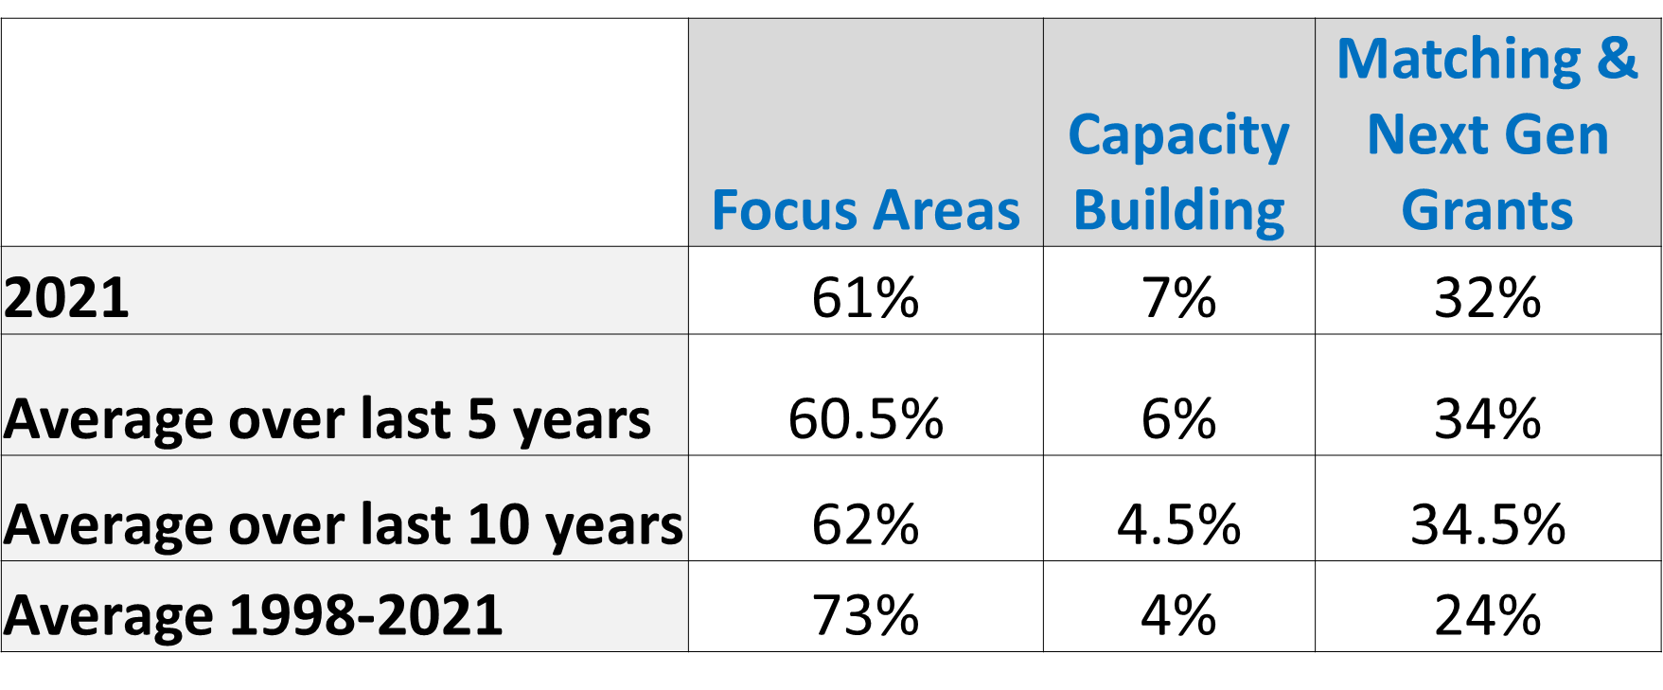  - Guidelines for % of TFF grant dollars awarded inside vs. outside of w. central IL  TFF also does not have a firm guideline on % of dollars to spend inside and outside of west central IL. Should we?  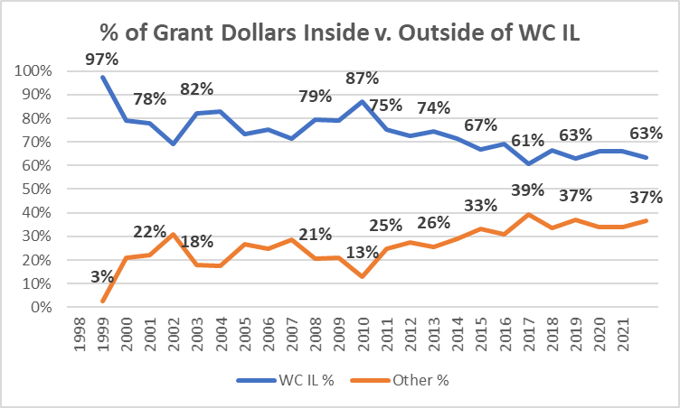  - Volunteer Incentive Program  There has been limited participation by the family in this program. Currently, qualifying volunteer activities only include service activities. The board discussed a proposal from the staff to also include service on a nonprofit board member as a qualifying activity. Staff recommended a volunteer incentive grant of $1,500 for organization per 12 months of board service.  - Multi-Year Grants  Dan laid out the pros and cons for TFF to consider providing multi-year grant funding.
CONCLUSIONS | Guidelines| The board should continue discussing.  Volunteer Incentive Program| Kristin made a motion to approve the recommended update to the Volunteer Incentive Program. Kenzie seconded the motion, and all were in favor.  Multi-Year Grants| The board should continue discussing.
Action items |  | Person responsible | Deadline
Provide trustees info on percentages broken out by Proactive and Reactive buckets. |  | Jean/Dan | 7/15/22
Provide trustees the dollar amounts (not just percentages) for % of grant dollars inside v. outside West Central IL |  | Jean/Dan | 7/15/22
Put a proposal together to bring to the board and retreat outlining proposed guidelines for grant bucket allocations. |  | Jean/Dan | 7/15/22
Draft guidelines for Multi-Year Grants. Run Multi-Year Grants info by Brady (GHS) to get feedback. |  | Dan | 7/15/22

TRACY FAMILY EDUCATION: DAN, MEGAN, & JEAN
Discussion | The board was updated on a collaborative effort of the Family Council and TFF to develop a Tracy Family Education curriculum. The hope is to launch it in Fall 2022.
CONCLUSIONS | The board was very supportive of developing an educational framework and curriculum for the family.
Action items |  | Person responsible | Deadline
Continue with development of the curriculum. |  | Erin, Dan, Megan, Jean | Fall 2022

BROWN COUNTY EARLY LEARNING CENTER (BCELC) and DOROTHY TRACY EDUCATION CENTER (DTEC): DAN & ANGIE

Discussion | Dan provided an update on BCELC and DTEC. Discussed was enrollment, tuition, parent and staff surveys, financials, and items being addressed now at the Center.

CONCLUSIONS
Action items |  | Person responsible | Deadline
FOCUS AREA, CAPACITY BUILDING, & NGAB UPDATES/Q&A: ALL TFF STAFF
Discussion | Dan did a call for questions/comments regarding the updates provided on Focus Areas, Capacity Building, and NGAB.

CONCLUSIONS
Action items |  | Person responsible | Deadline

TFF OFFICE: DAN
Discussion | TFF is currently renting a renovated house on Main Street owned by Rob Akright. The hope is to have a permanent TFF office. We have $50,000 in the 2022 TFF budget for office design fees. Dan has compiled an inventory of available space in Uptown Mt. Sterling those being:  - Jim Jennings Building  - Jasper Oil Building  - Building on Capitol next to Senior Center  - Don and Jill Tracy’s former office building  Questions to the Board: Is Main Street an essential location or should TFF consider options on Capitol? Should TFF’s office strategy be to find a dilapidated building and refurbish it?
CONCLUSIONS | Everyone agreed they would rather TFF put some roots down and have a permanent space. It is not essential that the TFF office be on Main Street. Capitol Street is just fine. We should find a dilapidated building and remodel it. We should design the building for TFF’s current and future needs but be flexible if someone wants to buy the building eventually.
Action items |  | Person responsible | Deadline
Continue exploring TFF office options. |  | Dan & Jean | 7/1/22

2022 DASHBOARD: DAN
Discussion | Dan reviewed the Key Performance Indicators on the Dashboard provided to the board. There was then a call for questions and suggestions.

CONCLUSIONS
Action items |  | Person responsible | Deadline
Add Volunteer Incentive Program participation rates to the TFF Dashboard. |  | Dan | 7/15/22

TFF RETREAT DATE CHANGE: JEAN
Discussion | The TFF Retreat was originally scheduled for October 7-8. Jean inquired if the move to the Oct. 14 & 15 date would work.
CONCLUSIONS | The change to Oct. 14 & 15 will work.
Action items |  | Person responsible | Deadline
Note TFF Retreat date change in your calendars |  | Everyone | 5/1/22

ADJOURN: JEAN
Discussion | Kenzie made a motion to adjourn the meeting at 4:45 p.m. Ben seconded the motion, and all were in favor.

CONCLUSIONS
Action items |  | Person responsible | Deadline

MEETING DAY TWO: APRIL 13, 2022

OPENING PRAYER: SUSIE
Discussion | Susie opened the meeting with a prayer. Thank you, Susie!

CONCLUSIONS
Action items |  | Person responsible | Deadline
Assign prayer to someone for the July board meeting |  | Susie | 07/01/2022

2022 YEAR-TO-DATE FINANCIALS: DAN & KRISTIN
DISCUSSION | Dan reviewed the TFF End of Year Investment and Cash Balance Guideline with the board which states: the Foundation should seek to finish the year with a minimum investment and cash balance that exceeds the greater of the following amounts: 1) Average of the prior 2 years total expenditures or 2) Incoming year’s budgeted expenditures. The Foundation should seek to finish the year with an investment and cash balance that does not exceed twice the minimum balance.  The red line in the graph below represents the minimum investment and cash balance to maintain and the green line represents the maximum investment and cash balance to maintain. We are in compliance with the Guideline.  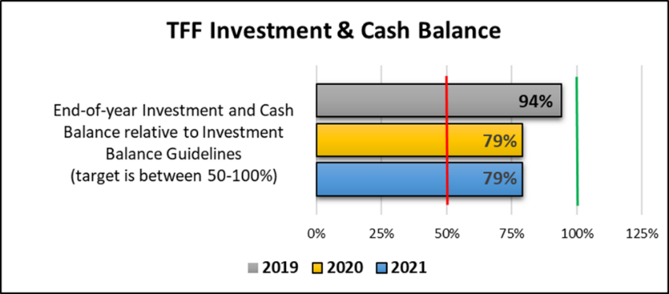  Kristin presented the year-to-date financial report as of 2/28/22.

CONCLUSIONS
Action items |  | Person responsible | Deadline
Add to the Dashboard the % of net investment assets that TFF awards annually. |  | Dan | 7/1/22

INVESTMENT COMMITTEE REPORT: DAN
Discussion | Dan reported that the transition to JP Morgan as the TFF Investment Advisor has gone smoothly. The TFF Investment Policy is in the process of being reviewed. TFF expenses are expected to exceed income in 2022 so there will likely be a need to raise cash from our investment portfolio this year. The board discussed the possibility of setting up a checking account at JP Morgan, which would replace Brown County State Bank in Mt. Sterling as TFF’s local checking account. There was strong resistance to this idea. The board feels it is very important to continue to use a local bank to process checks.

Conclusion
Action items |  | Person responsible | Deadline
Provide a recommendation to the board for a revised Investment Policy Statement |  | Dan | 7/15/21

STAFF UPDATE – FINANCE MANAGER: DAN
Discussion | TFF is seeking to hire a TFF Finance Manager. To date, we have had 7 applicants, but have not yet found the right candidate. To attract additional candidates, we are considering alternative job titles, shortening the job description, and distributing the job posting directly from TFF rather than through Dot.

CONCLUSIONS
Action items |  | Person responsible | Deadline
Continue working to fill the position. |  | Dan | 5/1/22

PRESIDENT TRANSITION PLAN: JEAN
Discussion | The transition plan will be announced in August with a hope of having the next leader announced by December. Jean solicited feedback on the plan. Below are the questions and conclusions.  Questions: Should the position be advertised as that of a traditional board Chair? Or should we be open to the position being a full-time or part-time job with the individual serving as both staff and board Chair?  Conclusion: Consider providing both options to the family and leave it to the Nominating Committee to decide whether the candidate has the interest and skills to serve on TFF Staff.  NOTE: The board revisited this conclusion during the Executive Session and changed their opinion. The board has now concluded that the role of the next TFF board leader should serve as a traditional board chair. Positioning the role as such will provide for clearer roles and expectations of the board chair and the Executive Director. In addition, it will be a fresh start and approach for the next 25 years of TFF which should help the individual who takes on the role understand that they don’t have to be “Jean”. The board also concluded that Dan should not serve on the Nominating Committee but should interview the top candidate(s) and share his opinion.  Question: Which option do you feel is best for the title?  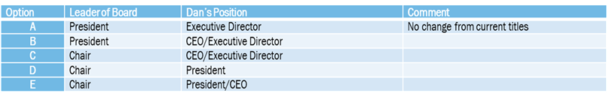  Conclusion: Option C was preferred. Most agreed the title “President” should be changed to “Chair”. There was some concern with having a CEO title if we don’t have a CFO title.  Question: Do you have any suggestions for the Job Description?  Conclusion: Pare down the job description so it is not so overwhelming and lengthy.  Question: Do you have any thoughts on time commitment/expectation?  Feedback: It will depend on the job descriptions.  Question: Should the next board leader be a Tracy family member?  Conclusion: Everyone agreed it should be a Tracy family member.  Question: Do you agree that 2Gs and 3Gs between the ages of 25-70 should be eligible to be the board leader?  Conclusion: Eligible 2G and 3G candidates need to be between ages 30 – 70.  Question: Do we want a maximum term limit or is this a position that someone might hold for 25+ years?  Conclusion: There is a preference that the expectation is that the minimum time to serve is 1 term (3 years) and the maximum time is 3 terms (9 years).  Questions: Does the next board leader need to live in west central IL? How often does the individual have to commit to coming to WCI?  Conclusion: The next board leader does not have to live in WCI, but the individual needs to commit to being in WCI at least every 2 months, and perhaps more often in the first 6 months of this role  Question: What are your thoughts on compensation?  Feedback: There is no recommendation at this point. More thought needs to go into the time involved to serve in this position.  Question: In addition to inviting family members to apply should we also invite family members to nominate other family members for the position?  Conclusion: Yes.  Question: Should we form a Nominating Committee made up of one 2G Dot Family Director, Jean, Pat Smith, and two 3Gs? The Committee would be responsible for making a recommendation to the Dot Foods and TFF boards.  Conclusion: Everyone likes the make-up of the Nominating Committee, but suggested that one of the 3Gs on the Committee should be on the TFF board.  Question: Are there any changes to suggest to the ideal characteristics of the next board leader?  Conclusion: Pare down and emphasize that no one will have all the ideal characteristics. It was also suggested that a collaborative spirit with nonprofits be added as an ideal characteristic.
CONCLUSIONS | See above.
Action items |  | Person responsible | Deadline
Revise the Succession Plan based on feedback from the TFF board and Dot family directors. |  | Jean | 7/1/22

TRACY FAMILY PHILANTHROPIC PLATFORM: JEAN
Discussion | Feedback was solicited on a Tracy Family Philanthropic Platform memo that was part of the board packet. The document was focused on potential services that could be available to family members through the platform for a fee. Such a platform was identified in the TFF 2019-38 Long Range Plan as a critical area to address between 2020-2024.  Question to Board: What suggestions do you have to improve the document and communication to the family?  Feedback: Give some examples. In the introduction, personalize it more and give an example of a family member who already has a foundation and how this might impact them in some way. Divide the document into two parts. People want to know more about the menu of services. Figure out the form after that.  Question to Board: Who should this document be sent to? All 2Gs? All 3Gs?  Feedback: Send to all 2Gs and all 3Gs.  Question to Board: Who should the survey be sent to? All 2Gs? All 3Gs?  Feedback: Send it to everyone. Just tell them if this is relevant to you or your future, take the survey. Let them decide if they want to take the survey.

CONCLUSIONS
Action items |  | Person responsible | Deadline
Survey 2Gs and 3Gs to better understand the specific services family members are interested in accessing for a fee. |  | Jean | 5/27/22
Contact Don & JP Morgan Team for law firm suggestions. Set up appointment with law firms to discuss framework. |  | Jean | June 2022

POLICY REVIEW: JEAN
Discussion | Jean shared recommended changes to the Grant Authorization Policy and Gift Acceptance Policy. A summary of the changes is noted below.  GRANT AUTHORIZATION POLICY:  Summary of Recommended Changes:  a) clarifies that the board, staff, or committees can be assigned to review any grants < than $49,999 – rather than just those that are between $10,001-$49,000 and b) increases the dollar amount from $10K to $15K for grants that can be reviewed by NGAB.  GIFT ACCEPTANCE POLICY:  Summary of Recommended Changes:  Redraft of original policy. Jean sent it to Jim Tracy and Liz Tracy. They think the redraft provides more clarity.
CONCLUSIONS | Ben made a motion to approve the changes to the Grant Authorization Policy. Susie seconded the motion, and all were in favor.  Wanda made a motion to approve the changes to the Gift Acceptance Policy. Tim seconded the motion, and all were in favor.
Action items |  | Person responsible | Deadline
Upload revised policies to the TFF website. |  | Kim | 6/1/22

25TH ANNIVERSARY CELEBRATION AND RETREAT: DAN
Discussion | The TFF 25th Anniversary Celebration and Retreat will be October 14-15 in Mt. Sterling. Dan shared the topics we expect to include at the retreat and asked the board to share what they would like covered.  Question: What would you like to have as a part of the 2022 Retreat?  Feedback:  - Have the 3Gs to be a part of it, not just the 2Gs speaking.  - Make babysitting available. Allow people to come for a half day.  - Talk about the Volunteer Incentive Program. Invite people who have participated this year to share their experience with it.  - Table work is good, moving people around is good. Every table should have a 3G leader instead of a 2G. Encourage engagement at tables and then share table conversation highlights with the group. Have tables talk about large projects.  - Take a big group picture  - Tastee Treet!  - President Transition Plan  - Get grantees to come in and talk about what TFF has done for them.  - Have someone from the Mental Health arena come in to speak.  - Downtown highlights.  - What is the board spending a lot of time on right now? What is the staff spending a lot of time on right now? What are the key highlights?  - Get feedback from 2Gs and 3Gs on Education Platform. Specific questions about what would be helpful for people to be educated on. Where do you feel you’re confused/intimidated/unsure?

CONCLUSIONS
Action items |  | Person responsible | Deadline
Let staff know if you have other ideas for the retreat. |  | All board members | 8/1/22

NEXT MEETING DATES & EXPONENT PHILANTHROPY CONFERENCE DATES: JEAN
Discussion | Exponent Philanthropy Conference:  Date: October 10-12, 2022  Location: Minneapolis, MN  Of note: It is not a requirement to attend, but we do encourage trustees to attend if interested. This is a good opportunity to network with a lot of other family foundations from across the U.S.  2022 Board Meetings:  July 27: Dot Foods, Mt. Sterling, IL  December 1: Dot Foods, Chesterfield, MO  December 19: Zoom Call 11:30 – 1:00 CST

CONCLUSIONS
Action items |  | Person responsible | Deadline
Let Dan know if you would like to attend the Exponent Philanthropy conference. |  | All Board Members | 7/1/22

ADJOURN: JEAN
Discussion | Linda made a motion to adjourn the meeting at 10:45 a.m. Ben seconded the motion, and all were in favor.

CONCLUSIONS
Action items |  | Person responsible | Deadline

AN EXECUTIVE SESSION WAS HELD IMMEDIATELY FOLLOWING THE BOARD MEETING. THERE ARE SEPARATE MINUTES FOR THE EXECUTIVE SESSION.

SUBMITTED BY (TFF ADMIN): | Kim Bielik
APPROVED BY (TFF SECRETARY):

APPROVED BY (TFF PRESIDENT):

