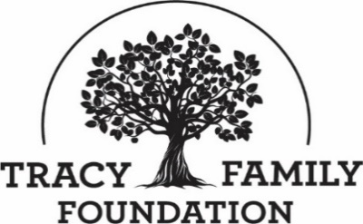

Tracy Family Foundation Board Meeting Minutes

DATE: | July 27, 2022
TIME: | 8:30 a.m. – 3:30 p.m., then Executive Session
LOCATION: | Dot Foods: Mt. Sterling, IL
TRUSTEE ATTENDEES: | Jean Buckley, Susie Stamerjohn, Wanda Tracy, Ben Tracy, Kristin Tracy, Linda Tracy, Kenzie Tracy, Mark Yingling, Sam Sullivan, Tim Curtin
ZOOM ATTENDEES (PARTIAL PORTION OF MEETING): | Brady Whitney (Grey, Hunter, Stenn)  Brandon Moritz, Jack Plym, Sarah Berg, Ben Posin, Neil Desai (JP Morgan)
MINUTES/STAFF ATTENDEE: | Kim Bielik
TFF STAFF ATTENDEE: | Dan Teefey, Terry Jenkins (Terry present for grant section only)

WELCOME & OPENING PRAYER: JEAN & SAM
Discussion | Jean welcomed everyone to the meeting. Sam opened the meeting with a prayer.

CONCLUSIONS
Action items |  | Person responsible | Deadline
Assign someone to open the December board meeting with a prayer. |  | Sam | 11/01/2022

ABOUT ROBERT & DOROTHY TRACY: BEN
Discussion | Ben shared a couple memories about RT and Dorothy. RT was a man of few words, and you didn’t try to get out of line with him, but it was always enjoyable spending time with him. Ben remembers being nervous the first time he mowed RTs lawn as a kid. RT popped out of nowhere to help get the lines straight when needed! Dorothy made visits with the grandkids very special. It was always a lot of fun to get to spend the night at their house and go to their house for breakfast after church. There were a lot of memorable experiences and special times with them!

CONCLUSIONS
Action items |  | Person responsible | Deadline

APPROVE MINUTES: JEAN
Discussion | Jean asked for a motion to approve the 4/12/2022 – 4/13/2022 board minutes.
CONCLUSIONS | Mark made a motion to approve the 4/12/2022 – 4/13/2022 board minutes. Kenzie seconded the motion, and all were in favor.
Action items |  | Person responsible | Deadline
Secure DocuSign signatures |  | Jean | 1/1/2023

STAFF, COMMITTEE, AND BOARD UPDATE: DAN & JEAN
Discussion | BOARD  - Terms Expiring on 12/31/22: Kenzie Tracy, Sam Sullivan, Susan Stamerjohn, and Wanda Tracy.  - Terms to Fill: Two 3-year terms and two 1-year terms. One of the 3-year terms will need to be filled by the person who will be the next board chair in 2024 (could be a 2G or 3G).  The TFF Bylaws require that 2 of 10 seats be occupied by 2Gs, 3 of 10 seats be occupied by 3Gs (with 2 of those seats being 1-year terms), and 2 of 10 seats be occupied by non-family, meaning not direct descendants of Robert & Dorothy Tracy. There is no limit on the number of terms a board member can serve.  STAFF  - Finance Manager: We didn’t have as many applicants as we’d hoped in the first round. For the second round, TFF posted the position instead of posting through Dot. We had 15 applicants and will be interviewing 4 applicants. We have also talked to outside accounting firms to have some backup options.  - Program Manager: This summer Megan Costigan went from part-time to full-time as the TFF Program Manager. Megan’s work includes Tracy Family engagement, work in the Youth Focus Area, and Brown County projects.  COMMITTEES  - Compensation Committee: Tim Curtin (Chair), Linda Tracy, Ben Tracy, Rob Tracy, and Kevin Bird.  - Nominating Committee: Jean Buckley (Chair), Pat Smith, 2G Dot Family Director, two 3Gs.

CONCLUSIONS
Action items |  | Person responsible | Deadline
Contact Jean if you have candidates to suggest for the board seats that need filled for 2023 |  | All Board Members | 9/15/22
Select two 3Gs to serve on the Nominating Committee |  | Jean | 9/15/22

PREPARING FOR THE FUTURE – TRACY FAMILY PHILANTHROPIC SURVEY RESULTS: JEAN
Discussion | A Tracy Family Philanthropic Survey was sent to 2G and 3G family members. The purpose was to learn about which services family members are interested in relative to administration of their own personal philanthropy and to collect personal philanthropy data. Jean provided an update on the survey results.  Next Steps:  - Gather benchmarking data on services and share that data with the 2Gs who have private foundations.  - Seek legal counsel on next steps.  - Put together informational packets and materials for family members that are considering starting a private foundation or a Donor Advised Fund  - Develop packet of materials for families with DAFs that provides a framework for their family discussions about focus, values, rules, etc.  - Draft the framework for a TFF Managed Giving Account.
CONCLUSIONS | These are the appropriate next steps.
Action items |  | Person responsible | Deadline
Continue working on the Philanthropic Platform. |  | Jean | 2023

PREPARING FOR THE FUTURE – BIG PROJECT IDEAS: JEAN
Discussion | Over the past couple of years, big project ideas have been solicited from the board, staff, and Tracy family members. These ideas were compiled into one document and are intended to be used for the following purposes:  1.Tracy Family Personal Philanthropic Journey Support| Help family members envision, drive, support projects through their own PF or DAFs.  2. TFF Long Term Planning| To prepare for the future and long-term planning as the dollars available to TFF continue to increase.  3. Inspiration & Collaboration| To inspire the family to rally around a big project(s) and support through a collaborative funding effort  4. Visioning| What could be undertaken if an increase of % of pre-tax profits from Dot where available to TFF?  5. Estate Planning| To be a springboard for a discussion with family members regarding their plans to leave part of their estate to TFF.  Next Steps:  - Pat Tracy will meet with John, Joe, and Dick to learn about their appetite for increasing the Dot contribution.  - Dan and/or Jean will meet with the family members that shared they have named TFF as a recipient in their estate plans.  - Staff discussion. Are there any large projects that should be prioritized now?
CONCLUSIONS | The format presented to the board will work for the described purposes.
Action items |  | Person responsible | Deadline
Approach John, Joe, and Dick about their interest in increasing Dot’s % of pre-tax profits that is contributed to TFF |  | Jean & Pat Tracy | 9/15/22
Review projects and consider if any should be researched and/or prioritized in the very near future |  | Dan & Staff | 12/01/22
Develop a plan to approach family members that have identified TFF as a recipient in their estate plan |  | Jean & Dan | 11/1/22

2022 YEAR-TO-DATE FINANCIALS: DAN & KRISTIN
DISCUSSION | FINANCIAL REPORT: KRISTIN  Kristin presented the year-to-date financial report as of 6/30/22.  2021 AUDIT AND IRS TAX FILINGS: BRADY WHITNEY  Brady Whitney from Grey, Hunter, Stenn joined us via Zoom. Brady is the primary person TFF works with in preparing our audit and 990’s. Brady walked the board through the 2021 Audit, as well as the state and federal reports that TFF and our related entities are required to file.  INVESTMENT AND CASH BALANCE: DAN  Dan reviewed the TFF End of Year Investment and Cash Balance Guideline with the board which states: the Foundation should seek to finish the year with a minimum investment and cash balance that exceeds the greater of the following amounts: 1) Average of the prior 2 years total expenditures or 2) Incoming year’s budgeted expenditures. The Foundation should seek to finish the year with an investment and cash balance that does not exceed twice the minimum balance.  The red line in the graph below represents the minimum investment and cash balance to maintain and the green line represents the maximum investment and cash balance to maintain.  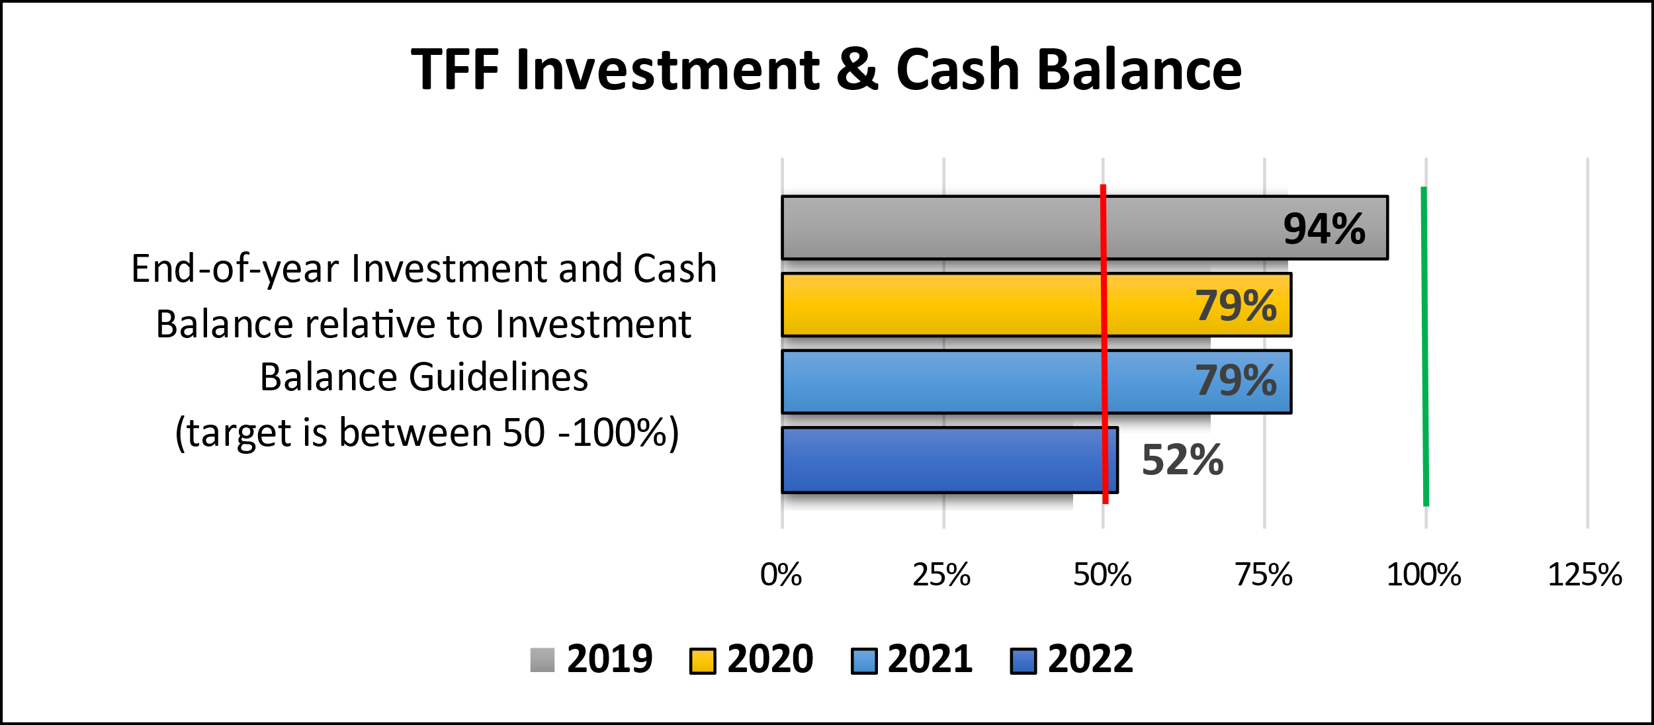
CONCLUSIONS | This is a prediction of the end of the year balance based upon the present market conditions. If the year ended today, we are in compliance with the Guideline. However, depending on how the second half of the year goes with the market, we could need to be conservative with expenditures to stay within the guidelines.
Action items |  | Person responsible | Deadline
Include the previous year numbers in financial report info. (i.e., have June 30, 2021, as well as June 30, 2022 info). |  | Kristin | 12/1/22

INVESTMENT COMMITTEE REPORT: JEAN, DAN, & JP MORGAN
Discussion | Brandon Moritz, Jack Plym, Sarah Berg, Ben Posin, and Neil Desai from JP Morgan joined us via Zoom. Brandon and Jack are TFF’s two primary contacts and advisors.  The TFF Investment Committee, alongside JP Morgan, has drafted a revised Investment Policy Statement (IPS). Jack walked the board through the revision process and changes to the IPS. Brandon and Jack also provided highlights on the TFF Investment Portfolio.  QUESTIONS TFF HAS FOR JP MORGAN  - US Small Cap – Why is this at 0%?  - Why the large range?  - How often do you rebalance the portfolio?  - How long will the transition take for allocations?
Conclusion | Jean asked for a motion to approve the revised Investment Policy Statement. Tim made a motion to approve the revised Investment Policy Statement. Susie seconded the motion, and all were in favor.
Action items |  | Person responsible | Deadline
Get answers from JP Morgan on questions above |  | Dan | 9/1/22

GRANT APPLICATION REVIEW & FUNDING DECISIONS: DAN & TERRY
Discussion | Jean reminded everyone of the TFF Conflict of Interest Disclosure. The board then moved forward with making funding decisions. Dan reported on Grant Variance decisions, Staff Discretionary Grant decisions, and Invitation Grant approvals.
CONCLUSIONS | Funding decisions are noted below.  GRANT APPROVALS  - Junior Achievement of Greater St. Louis: $25,000  - Rushville Industry High School: $20,000  - Young Life Quincy: $20,000  - Brown County Community Unit School District #1: $2,866.52  - Brown County Community Unit School District #1: $14,977.18  - Brown County Community Unit School District #1: $6,075  - Blessed Sacrament Catholic School: $30,000  - St. Dominic School: $30,000  - St. Mary School – Mt. Sterling (remediation & tech): $30,000  - St. Mary School – Mt. Sterling (enrollment grant): $600 x number of students enrolled - $511.21  - St. Peter School (Intervention Specialist): $30,000  - St. Peter School (Reading Recovery): $40,000 (pending FIR)  - Sts. Peter & Paul School: $30,000 (after start of school year)  - Western Illinois Youth Camp: $8,640 (post Site Visit)  - Cornerstone: $25,000  - Camp Point Central CUSD 3: $33,574.94  - Griggsville Perry High School: $13,000  - Winchester Grade School: $25,000  - Chaddock Children’s Foundation: authorized Dan to approve up to $17,400.  - Schuyler County Mental Health: $30,000  - Action Brown County: $25,000  - Chaddock (leadership academy): $25,000  - Clayton Public Library District: $5,000  - Colchester District Library: $5,000  - Garrison School: $2,400  - Greater West Central Public Library District: $5,000  - Hamilton Public Library: $5,000  - John Wood Community College Foundation (BCHS Senior Dual Enrollment): $28,960 (pending FIR)  - John Wood Community College Foundation (College for Life): $15,842 (pending FIR)  - John Wood Community College Foundation: $11,500  - Learning Technology Center of IL: up to $10,000…reimburse at $250/person from west central IL  - Liberty CUSD #2: $9,490  - Scott/Morgan #2: $20,000  - Pikeland School District (Open Parachute): $19,500  - Virginia School District: $2,750  - Western School District: $8,400  - St. Paul School: up to $3,025  - Winchester School District: $7,275  - Winchester Public Library: $5,000  - Camp Point Central Middle School: $19,475  - North Greene School District: $20,000  - Pikeland School District (curriculum alignment): $20,000  - Adopt-A-Classroom: up to $20,000  - Mt. Sterling Community Center YMCA: $1,635  - Farwell House: $7,500  - Greater St. Louis Area Boy Scouts of America: $2,875  - Quincy Symphony Orchestra Association: $12,000  CHALLENGE GRANTS  - John Wood Community College Foundation (College for Life): $5,000 (1:1, new donors by 12/1/22)  SITE VISITS  - Illinois College| authorized Dan to approve up to $16,900  - Brown County Community Unit School District #1 for SEL Counselor| authorized Dan to approve up to $60,000  - Brown County Community Unit School District #1 – ELA Textbooks| authorized Dan to approve up to $34,583  - Western Illinois Youth Camp  - Be Strong Families (authorized Dan to approve up to $10,000)  - 100 Club of Illinois  DENIED FUNDING  - Madison Park Christian Church  INVITATION GRANT APPROVALS  - The Outlet: $15,000  - Lift for Life Academy: $30,000  - St. Joseph Housing Initiative: $30,000  - St. Louis Learning Disabilities Association: $15,000  REQUESTS FOR GRANT VARIANCE  - St. Mary School, Taylorville: $7,500 - Approved

CONCLUSION

Moving forward, we will have a TFF Staff review the library grants and authorize Dan to approve the grants.
Action items |  | Person responsible | Deadline
Process grants |  | Kim and Dan | 08/27/2022
Schedule Site Visits |  | Dan | 11/1/22
Report on Site Visit decisions at board meetings |  | Dan | 12/1/22
Send Final Impact Report example to trustees |  | Dan | 11/1/22
Revise Grant Authorization Policy to note review and approval by whom for library grants |  | Jean | 10/1/22

DOROTHY TRACY (DT) ESTATE GIFT: DAN
Discussion | Dan walked the trustees through the details of the $1.8M DT Estate Gift, which the board restricted to Brown County projects. He then provided a status update and led a discussion on the potential projects.  GRANTS AWARDED TO DATE  - St. Mary – Windows: $99,998  - Holy Family – Renovations: $331,570 (not yet paid)  - Remaining Balance: $1,422,858  PROJECTS  - Holy Family/St. Mary School – Facility Improvements: Roof is currently in process of being replaced.  - Brown County Public Library – New Library Construction: Their goal is still to break ground in the fall.  - Brown County Trailways: Engineering and development work is being done on the Memorial Trail. ITEP has a grant opportunity that Brown County will apply for between August 1 – September 30.  - Mt. Sterling Park District – Joel Oliver Memorial Swimming Pool Improvements: They applied for and received a $400,000 matching grant. They must raise $400,000 to receive those funds.  QUESTIONS FOR DISCUSSION  Q: The Joel Oliver Memorial Swimming Pool will need $400,000 in matching funds for its project. Is that a project TFF is interested in supporting?  A: Yes, there is an appetite to support. No decisions made at this time.  Q: Should we consider $400,000 to construct the first trails at Clark Park in Mt. Sterling?  A: Yes, there is an appetite to support. No decisions made at this time. Suggestion was made to name it Dorothy Tracy Memorial Trail.  Q: The Trails project will require 20% matching funds for up to $3M. Is that a project TFF is interested in supporting?  A: Yes, there is an appetite to support. No decisions made at this time.
CONCLUSIONS | See above.
Action items |  | Person responsible | Deadline
Inquire about the Holy Family Church internal remodeling needs. |  | Dan | 12/1/22

BROWN COUNTY EARLY LEARNING CENTER (BCELC) & DOROTHY TRACY EDUCATION CENTER (DTEC) UPDATES: DAN
Discussion | Dan provided an update on BCELC. Discussed was enrollment, tuition, financials, staffing, and items being addressed now at the Center.  Dan also reported that DTEC has an ongoing property tax appeal with the IL Dept of Revenue. They denied the sales tax exemption for both BCELC and DTEC as well as the property tax exemption for DTEC. We appealed the decision which has resulted in $15,000 in attorney fees. We received a property tax bill for a little over $21,000 for DTEC which is due in Fall 2022.  BOARD ACTION  Dan asked the board to approve up to $55,000 in grants to DTEC. We have budgeted $15,000 but we need additional funds to cover the taxes and the attorney fees.  QUESTIONS FOR DISCUSSION  The BC Early Learning Center has received more than $50,000 in government subsidy in 2022.  Q: Should we consider giving the current families a free week of tuition for their endurance during Covid? The lost revenue would be approximately $10,000.  Feedback:  - The Foundation is already subsidizing, maybe the money would be better used in a different way for the center.  - Families might expect this going forward if we start it now.  - Everyone wouldn’t benefit.  We’ll know a lot more in December, so we’ll talk about this again then.
CONCLUSIONS | Wanda made a motion to approve up to $55,000 in grants to the Dorothy Tracy Education Center. Kenzie seconded the motion, and all were in favor.  Note: Mark Yingling is on Brown County board of review for property tax assessments, so he did not vote on this.
Action items |  | Person responsible | Deadline

GRANT PROGRAMS & APPROACHES: JEAN & DAN
Discussion | The board reviewed some of the current grant programs and giving approaches. Below is a summary of the discussions.  GUIDELINES FOR % OF TOTAL GRANT DOLLARS BY PROGRAM AREAS  TFF has never had a firm policy about the percentage of dollars to allocate to the Focus Areas, Capacity Building, and Matching and Next Gen grants. Jean shared and discussed the table below, which includes Dan and Jean’s recommendation:  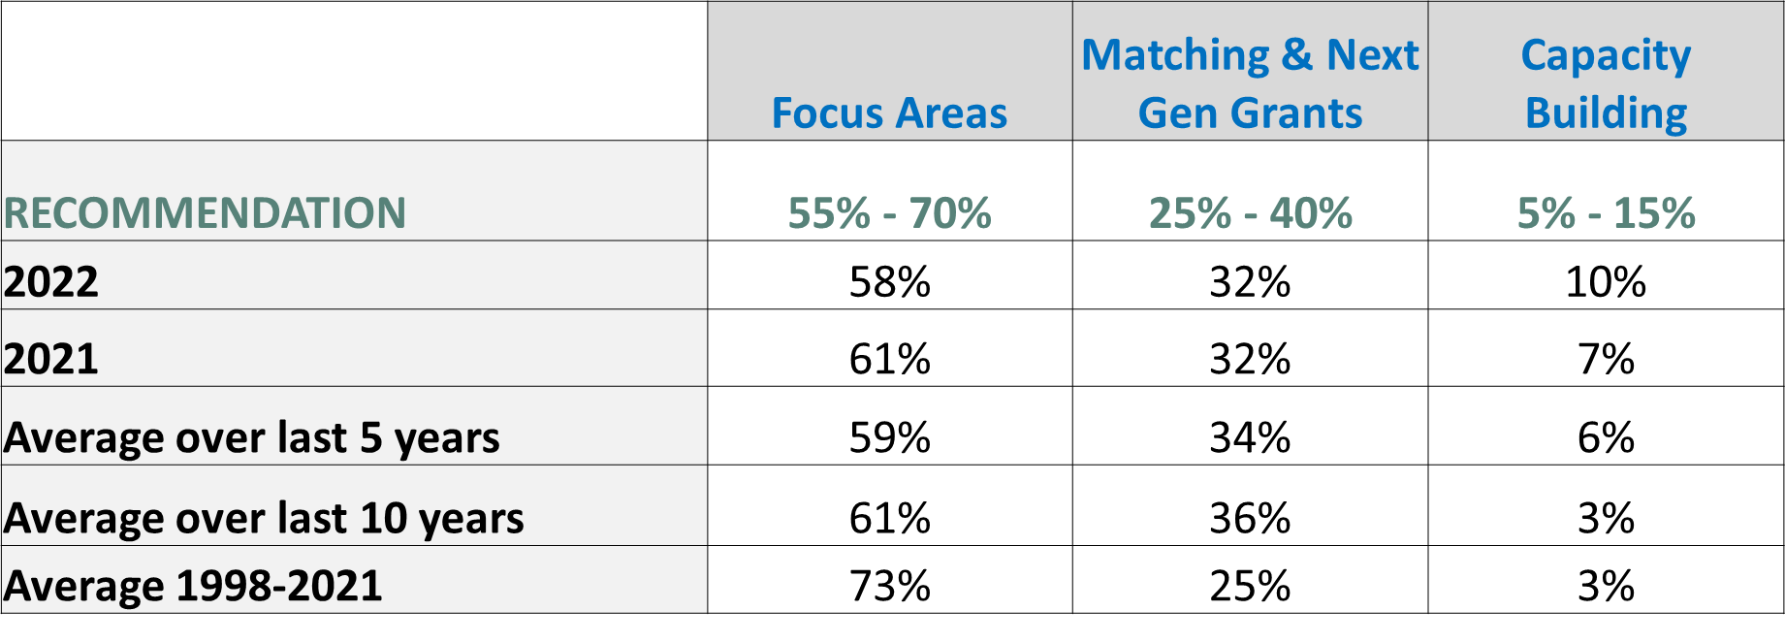  Everyone agreed that having such a guideline in place would provide direction to the board and staff. However, we will postpone a decision until December as we would like to also get input from Tracy family members and a NCFP study that is being done on this issue.  GUIDELINES FOR % OF TFF GRANT DOLLARS AWARDED INSIDE VS. OUTSIDE WEST CENTRAL IL  TFF also does not have a firm guideline on % of dollars to spend inside and outside of west central IL. Jean shared stats on the % of grant dollars inside vs. outside west central IL.  After some discussion, everyone agreed that it makes sense to create guidelines and have guardrails in place to protect giving in west central IL and Brown County. This issue will be discussed at the TFF Retreat.  GUIDELINES FOR % OF TFF GRANT DOLLARS AWARDED RESPONSIVE VS. PROACTIVE  Jean shared and discussed the table below, which includes Dan and Jean’s recommendation:  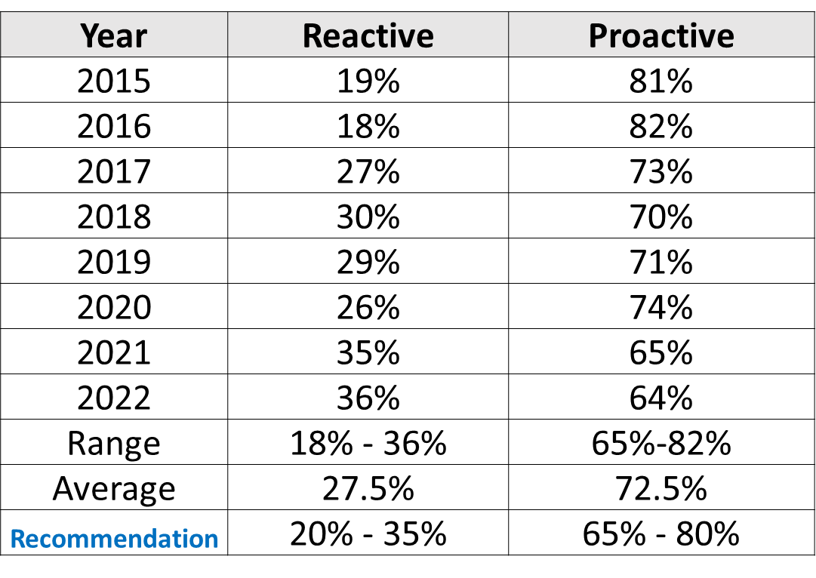  MULTI-YEAR PROJECTS AND/OR PROGRAMS GUIDELINES  Dan discussed the pros and cons for TFF to consider funding for multi-year projects and/or programs. He also outlined the potential process and potential candidates. Everyone agreed that if this is not a lot more work on TFF staff, it is a great plan.  This plan would require a change to our Grant Authorization Policy, as follows:  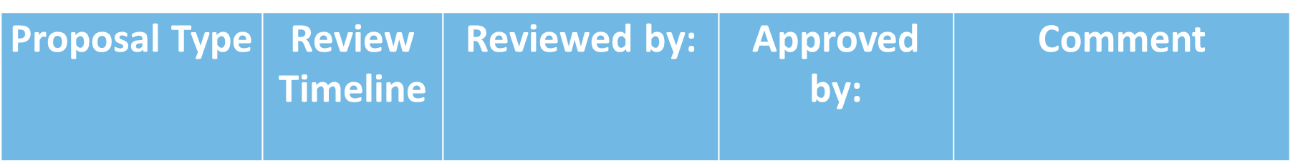  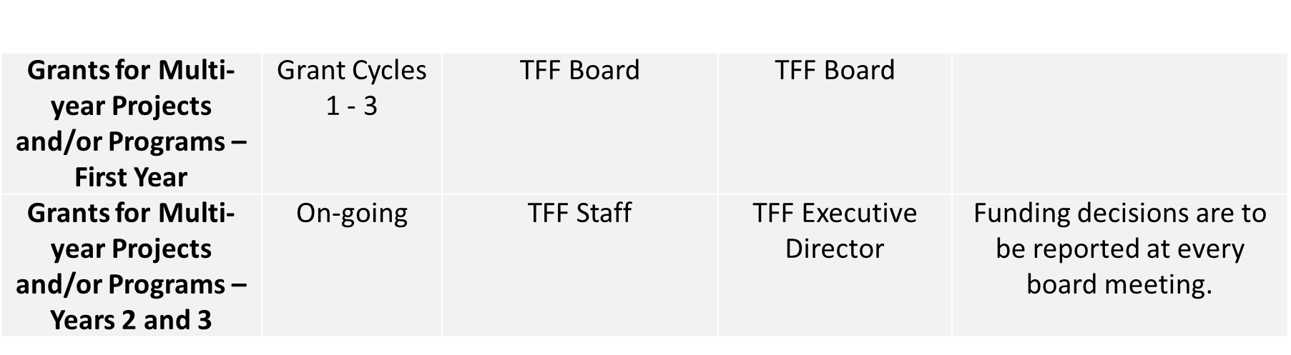  BCHS SCHOLARSHIP PROGRAM  Dan shared stats on scholarships awarded 2011 to the present. In 2022 there are 23 scholarship recipients.  Currently, the scholarship guidelines call for 30 new scholarships per year, with 15 to award for 4-year college scholarships and 15 for 2-year community college and technical school scholarships. Dan proposed that we continue to offer up to 30 new scholarships per year, but not dictate the number that are allotted to four-year vs. two-year schools. Dan provided a cost comparison if the proposal is approved.  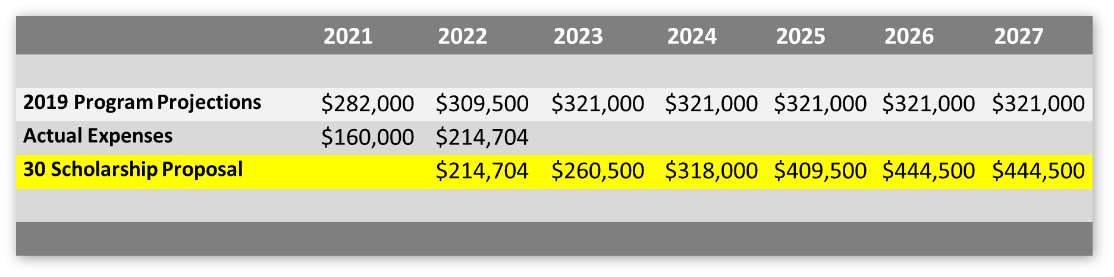  Note: $10,000 Scholarship America administrative fee not included  The 30 Scholarship Proposal presumes:  - 2 career/tech @ $2,500 for two years  - 6 that will start at community college, then transfer to 4-year university  - 22 that will start and complete at a 4-year university
CONCLUSIONS | % of Dollars to Budget by Program Area: No conclusion.
 | % of Dollars to Budget Inside and Outside of West Central IL: No conclusion.
 | % of Dollars to Budget for Pro-Active vs. Re-Active: Ben made motion to approve the following range: 20-35% Responsive, 65-80% Proactive. Mark seconded the motion, and all were in favor.
 | Tim made a motion to approve the Multi-Year Project and/or Program Guidelines noted above. Kristin seconded the motion, and all were in favor.
 | Susie made a motion to approve the changes to the Grant Authorization Policy related to Grants for Multi-year Projects and/or Programs . Wanda seconded the motion, and all were in favor.
 | Linda made a motion to approve changing the BCHS Scholarship Guidelines as such: up to 30 new scholarships per year may be awarded for either four-year or two-year scholarships. Ben seconded the motion, and all were in favor.
Action items |  | Person responsible | Deadline
Discuss % of Grant Dollars to Budget by Program and Geography at the TFF Retreat |  | Dan & Jean | 10/15/22
Make the approved changes to the Grant Authorization Policy |  | Jean | 10/1/22
Make the approved changes to the BCHS Scholarship Guidelines |  | Dan | 10/1/22

PRESIDENT TRANSITION PLAN: JEAN
Discussion | The President Transition Plan will be announced in August, with a hope of having the next leader announced by December. Jean asked for board feedback on the President Transition Plan.  FEEDBACK  - Add number of times they might need to travel to St. Louis for board meetings and travel for professional development.  - Is $25,000 enough to entice someone to do the job?  - There needs to be some flexibility on the division of duties.  Jean will send the information out to the family in the next week.
CONCLUSIONS | The Plan is ready to be sent to the family.
Action items |  | Person responsible | Deadline
Email the Plan to 2G and 3G Tracy family members. |  | Jean | 7/29/22

GUIDELINES & POLICIES REVIEW: DAN
Discussion | Dan shared recommended changes to the Youth Trip Guidelines and the Grant Authorization Policy. A summary of the changes is noted below.  YOUTH TRIP GUIDELINES  Summary of Recommended Changes:  Goal: To help organizations and churches send youth and adult chaperones on a service, learning, or spiritual trip that will help them develop into strong, healthy, and resilient youth.  Eligibility: Organizations within West Central Illinois and youth ages 10-18 years old. Trips must be at least 60 miles from the organization’s home and outside of West Central Illinois.  Grant Amount: TFF will pay the lesser of $150 or 50% per person participating in the trip up to a maximum of $25,000 per group, including youth and chaperones.  Review Process: TFF Staff will review applications on a rolling basis at their monthly meetings and the TFF Executive Director would be authorized to approve the grants like the Invitation Grant process.  GRANT AUTHORIZATION POLICY  Summary of Recommended Changes:  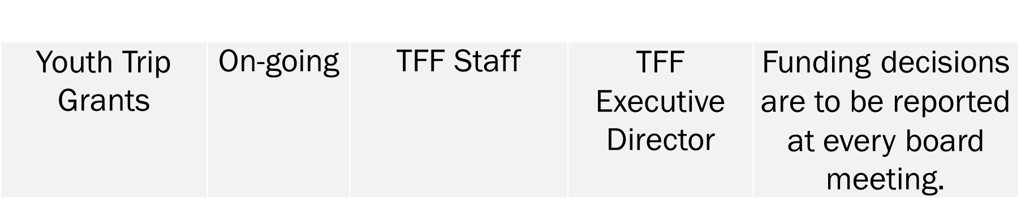
CONCLUSIONS | Linda made a motion to approve the changes to the Youth Trip Guidelines. Kenzie seconded the motion, and all were in favor.  Linda made a motion to approve the changes to the Grant Authorization Policy related to Youth Trip Grants. Susie seconded the motion, and all were in favor.
Action items |  | Person responsible | Deadline
Make approved changes to the Grant Authorization Policy |  | Jean | 9/15/22
Upload revised policies to the TFF website. |  | Kim | 09/01/2022

TFF OFFICE: DAN
Discussion | TFF is currently renting a renovated house on Main Street owned by Rob Akright. The hope is to have a permanent TFF office. We have $50,000 in the 2022 TFF budget for office design fees. Dan has compiled an inventory of available space in Uptown Mt. Sterling those being:  - Jim Jennings Building  - Jasper Oil Building  - Building on Capitol next to Senior Center  - Jesse Gilsdorf’ Law Office  What We’re Working on Now:  - Architechnics, an engineering firm from Quincy, is going to examine Jesse Gilsdorf’ law office on August 2.  - We’ll get a probable cost estimate for renovations and explore whether the building has sufficient space. (In 2017 the renovation estimate was $228,000).  - We’ll determine a purchase price for the building.

CONCLUSIONS
Action items |  | Person responsible | Deadline
Obtain a probable cost estimate from Architechnics |  | Dan | 9/15/22

TRACY FAMILY EDUCATION PLATFORM: JEAN
Discussion | Jean reported on the Tracy Family Education Platform that is being developed by the Family Council and TFF. Dan, Jean, Megan, and Erin are working on developing the framework. To date they have:  - Identified Learning Pathways| Our Family. Our Family Enterprise. Our Family Philanthropy. Our Family Finances.  - Identified Levels of Training| 101.201.301.401.  - Identified numerous educational topics for Levels of Training & Learning Pathways.  - Prioritized 3 trainings| Dot stock. New spouse orientation. Financial literacy.  - FC approved funding for Philanthropic Milestones Outreach to the family  The board was asked to consider names for the Platform. Tracy University was suggested.
CONCLUSIONS | No conclusions were reached regarding the name.
Action items |  | Person responsible | Deadline
If you think of any names for the platform, send the suggestions to Jean |  | Board Members | 12/1/22

25TH ANNIVERSARY CELEBRATION AND RETREAT: DAN
Discussion | The TFF 25th Anniversary Celebration and Retreat will be October 14-15 in Mt. Sterling. Tracy family, TFF Staff, and non-family trustees will be invited to RSVP for the retreat in August. Tours will be available for various attractions in Mt. Sterling. We are planning to offer childcare this year.  During the Retreat, we expect to include:  - Celebration of TFF’s 25 Years  - Highlights of projects in all TFF’s Focus Areas  - Breakout discussions to gather Tracy family feedback  - Update on TFF’s Long Range Plans  - Opportunity for Tracy family to share about their personal philanthropy  - Updates on potential Tracy family Philanthropic platform and Education Platform  - Discussion of Dorothy Tracy Estate Gift

CONCLUSIONS
Action items |  | Person responsible | Deadline

FOCUS AREA, CAPACITY BUILDING, & NGAB UPDATES/Q&A: DAN
Discussion | Dan did a call for questions/comments regarding the updates provided on Focus Areas, Capacity Building, and NGAB.  Jean said the Mental Health Committee is looking into starting an affiliate of NAMI in west central IL. She may ask the board for approval on this prior to the December board meeting.

CONCLUSIONS
Action items |  | Person responsible | Deadline

2022 DASHBOARD: DAN
Discussion | Dan reviewed the Key Performance Indicators on the Dashboard provided to the board. There was then a call for questions and suggestions.
CONCLUSIONS | The Dashboard is appreciated by the board.
Action items |  | Person responsible | Deadline

NEXT MEETING DATES & CONFERENCE DATES: JEAN
Discussion | BOARD MEETING DATES  Dec. 1| TFF Board Mtg (in-person): 9:00 – 4:30 / Chesterfield  Dec. 1| TFF Board & Staff Christmas Party: 5:00 – 8:00 (?) / Chesterfield  Dec. 19| Board Mtg (Zoom): 11:30 – 1:00  CONFERENCE OPPORTUNITIES  Oct. 10 – 12| Exponent Philanthropy / Minneapolis  Oct. 19 – 21| Philanthropy Roundtable / Palm Beach  Oct. 19 – 21| National Center for Family Philanthropy / San Francisco  TFF RETREAT  Oct. 14| Dinner Kick-off – Hagel / Mt. Sterling  Oct. 15| Retreat / Hagel

CONCLUSIONS
Action items |  | Person responsible | Deadline
Decide on December 1 meeting location. |  | Jean | 9/1/22

ADJOURN: JEAN
Discussion | Tim made a motion to adjourn the meeting at 3:30 p.m. Ben seconded the motion, and all were in favor.

CONCLUSIONS
Action items |  | Person responsible | Deadline

AN EXECUTIVE SESSION WAS HELD IMMEDIATELY FOLLOWING THE BOARD MEETING. THERE ARE SEPARATE MINUTES FOR THE EXECUTIVE SESSION.

SUBMITTED BY (TFF ADMIN): | Kim Bielik
APPROVED BY (TFF SECRETARY):

APPROVED BY (TFF PRESIDENT):

