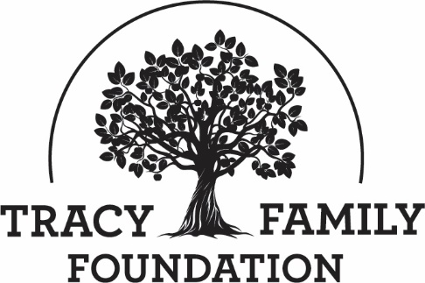

Tracy Family Foundation Board Meeting Minutes

DATE: | January 23, 2024
TIME: | 8:30 a.m. – 3:00 p.m.
LOCATION: | Dot Foods - Chesterfield, MO
TRUSTEE ATTENDEES: | Jean Buckley, Susie Stamerjohn, Jake Schlater, Jim Tracy, Tim Curtin, Linda Tracy, John Sullivan, Melanie Markay
TFF STAFF ATTENDEES: | Dan Teefey, Terry Jenkins, Angie Schlater, Megan Costigan, Robyn Pilliod, Kim Bielik

WELCOME & OPENING PRAYER: SUSIE & DAN
Discussion | Susie welcomed everyone to the meeting. She introduced the new board members (Melanie, John, and Jake). Dan opened the meeting with a prayer.

CONCLUSIONS
Action items |  | Person responsible | Deadline
Assign someone to lead with prayer at the April meeting. |  | Susie | 04/01/2024

SNAPSHOT OF ROBERT & DOROTHY TRACY: SUSIE
Discussion | Susie shared birthday pictures of Dorothy from years past. Dorothy made birthdays so special throughout the years!
Action items |  | Person responsible | Deadline
Assign someone to share memory/shapshot at the April meeting. |  | Susie | 04/01/2024

APPROVE MINUTES: SUSIE
Discussion | Susie asked for motions to approve the 12/01/2023 and 12/19/2023 board minutes.
CONCLUSIONS | Linda made a motion to approve the 12/01/2023 board minutes. Jim seconded the motion. All voted in favor.  Tim made a motion to approve the 12/19/2023 board minutes. John seconded the motion. All voted in favor.
Action items |  | Person responsible | Deadline
Secure DocuSign signatures on the approved minutes. |  | Jean | 02/15/2024

TFF COMPASSES: JEAN, DAN, & STAFF
Discussion | 2019-38 LONG RANGE PLAN – UPDATE / Q&A: JEAN  Jean explained why TFF has a 20-year plan and the methodology in developing the plan. She provided a status update and did a call for feedback and questions.  2020-24 LONG RANGE PLAN – UPDATE / Q&A: DAN  Dan provided an update on the 5-year plan. He shared highlights and did a call for feedback and questions.  2024 STAFF GOALS / Q&A: STAFF  Each TFF staff member highlighted 2024 goals, as follows:  Terry:  - GOAL: Complete the launch of a NAMI affiliate in WCI and provide oversight. Terry is in the process of completing the NAMI West Central IL affiliate application. He garnered a meeting with NAMI National and is in the process of getting facilitators set up for training in WCI.  - GOAL: Execute the Rural Behavioral Health Institute in WCI. This program is aimed at reducing youth suicide, anxiety, and depression. TFF is inviting this organization to submit a grant request for $80,000 to cover approximately 2,000 students for one year. If the TFF board approves this request, the program would be launched in the Fall of 2024.  - GOAL: Mental Health Listening and Engagement Tour. Terry plans to visit most, if not all, mental health providers in WCI to build relationships and get a better understanding of their view of needs. The hope is to ramp up mental health grant applications to TFF.  Megan:  - GOAL: Grow participation in the Tracy family 4G experience beyond 11. The purpose of this experience is to familiarize the 4th generation of the Tracy family with their Brown County roots. TFF is the legacy of RT and Dorothy Tracy so it is important for future generations to learn about the geographic roots of the Robert and Dorothy Tracy family. In 2023, 11 4Gs attended this BC experience. TFF will host another 4G Brown County Experience on June 22, 2024..  Kim:  - GOAL: Update Cybergrants communication and all TFF grant applications. Kim has created new Formal Grant applications for each TFF Focus Area, as well as set up routing and approval rules for each application type. These changes will allow each Program Manager to receive direct communication related to all grant requests for their Focus Area. It will also give each Program Manager added permissions, such as the ability to return applications to grantees for revision, do initial approvals, etc. This will also improve TFF reporting capabilities, making it easier to report on projects by Focus Area. Kim will update all Final Impact Reports and TFF communications as well.  Robyn:  - GOAL: Manage all transactions in QuickBooks online with 95% accuracy. Robyn researched and signed TFF up for Positive Pay (a cash management system used to identify forged checks). She has also developed a plan to adopt QuickBooks Online and transition accounting from an external company (ABNG) to TFF. Robyn will update existing account titles and develop a strong working knowledge of QuickBooks software. She will record all weekly cash transactions in QuickBooks and create templates to automate statement preparation. Robyn will also perform month-end accounting activities.  Angie:  - GOAL: Guide BC School District Strategic Planning to completion. Angie spoke to several strategic planning firms that focus on education and school districts. Getting Smart, the company selected for this work, has rural experience and a good price point. Kick-off is in January, with a 6-month timeline for the work. Education data metrics have been identified and data will continue to be collected.  - Other Information:  - Education Data: Angie provided data on Brown County and other public schools in West Central IL. The source of the majority of the data is the IL School Report Card. The Summative Designation given to each of the 3 BC public schools is Commendable. The only ranking above commendable is exemplary. There are two rankings below commendable.  - BC Public School Grant Fund| The TFF 2024 budget for this Fund has been increased to $300,000. TFF is hoping to get requests for projects that are tied to the district’s new Strategic Plan. She also shared that the Community Foundation Brown County Teacher Fund is running low, so TFF may seed the fund at $25,000. Action Brown County Board administers the distribution of this fund and will start a marketing campaign to help grow this fund.  Callie:  - GOAL: Dan shared a list of Callie’s 2024 goals. A few highlights: Facilitate 90% of TFF Capacity Building opportunities / Launch 2 new Capacity Building Programs / Analyze Capacity Building over the past 5 years and implement at least 1 program improvement.  Dan:  - GOAL: Launch dilapidated housing improvement plan. A lot of good work has already been done. They have a new team working on this project. The city now has a dilapidated housing color coded map to guide them with this work. The City of Mt. Sterling will apply in Cycle 1 2024. They will likely request funds for two purposes: 1. Funds to deal with homes that are uninhabitable that need to be torn down. 2. Funds to help build a program similar to our façade improvement program (TFF would provide funds for homeowners to make home improvements). The city is also going to commit funds for this project from cannabis and gaming income.  - GOAL: Marriage Enrichment work. The goal is to find ways to help couples in west central Illinois (WCI) have resources to start off and maintain good marriages. Dan is working on finding a consultant to aid in this. This would likely include a couple’s assessment which would help gather data which would help build out strategies for couples and provide tools and skilled based trainings for improvement.

CONCLUSIONS
Action items |  | Person responsible | Deadline
To help grow the Fund, communicate the CF Brown County Teacher Fund to the family and get ABC to market the CF Teacher Fund to the public. |  | Angie and Dan | 12/1/24
Share those “extra special” Thank You notes that come in from Matching Grant recipients with the Tracy family member that initiated the Matching Grant. | Kim & Dan | On-going

TFF 2025-2029 STRATEGIC PLAN: DAN
Discussion | TFF will issue an RFP for a consultant in February to facilitate the development of a 2025-2029 TFF Strategic Plan. The plan will be developed from April – December. This work will include conducting a grantee survey and getting Tracy family and TFF board feedback. We will focus more on strategies, infrastructure, timeline, and measurement. The plan will be aggressive to capture anticipated foundation growth. We will formally approve the plan at the first TFF Board meeting of 2025.  Feedback:  - TFF staff should be the ones to lead the process again, with input from the Tracy family and the TFF board.  - Work with consultants who know the process and the industry.  - Focus on consultants who are very familiar with the quantitative piece.

CONCLUSIONS
Action items |  | Person responsible | Deadline
Share with the board the most important thing TFF is trying to accomplish in the Strategic Plan. |  | Dan | 04/25/2024

2023 WRAP-UP: DAN & ROBYN
Discussion | Q4 2023 DASHBOARD: DAN  Dan shared the Dashboard slides and did a call for feedback and questions.  2023 YEAR-END FINANCIALS: ROBYN  The preliminary financials presented were through December 31, 2023. Below is a summary. It was noted that we did not have Dot’s Period 13 in-kind donations to TFF and a few other reconciliations that we’ll need to wrap up 2023.  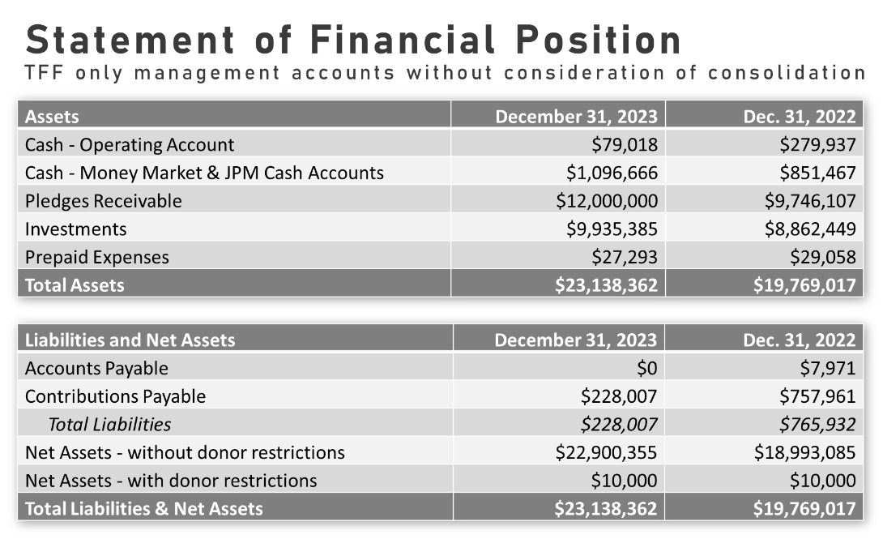  ____________________________________________________________________  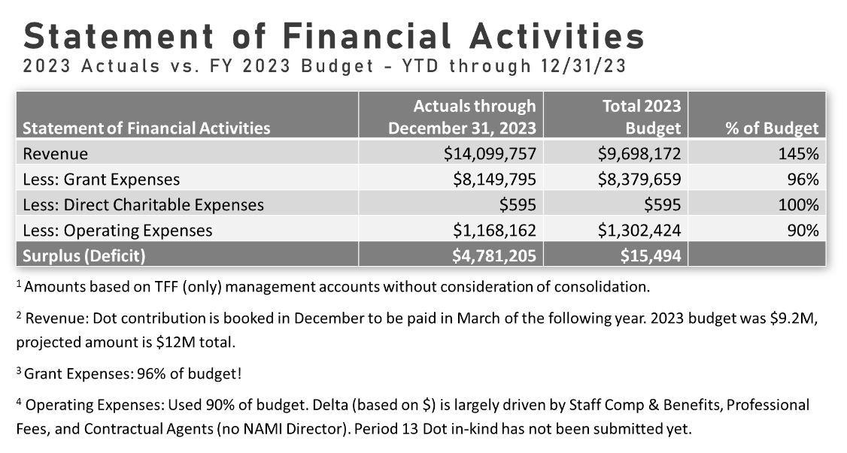  ____________________________________________________________________  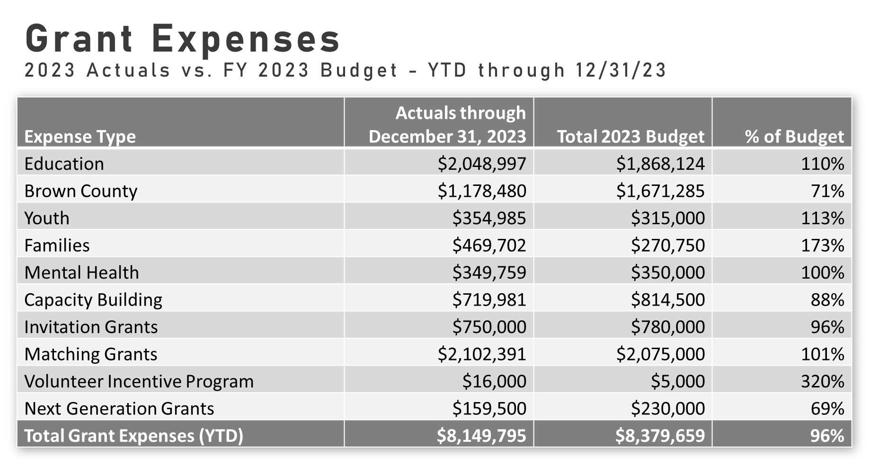  Items to Note:  Numbers are pre-audit, so there will be some changes.  - Statement of Financial Activities:  - The projected amount of Dot’s contribution is $12M (cash and in-kind) . The cash contribution will be closer to $11M.  - Grant Expenses:  - Brown County at 71% of budget is due to the BCELC receiving more funding from state of IL than anticipated (so $150k less). We had budgeted $300K for TFF’s match for the Lake Trail ITEP grant if awarded, but since it was not awarded we did not spend those funds. Families budget increased primarily due to more responsive grants in this category.  - We really pushed the Volunteer Incentive Program last year so that is up.  - Next Gen number was decreased because the TFF Board elected to award a $50,000 grant to Screen Sanity rather than the $100K that was budgeted.  - Total grant expenses ended up at 96% of budget. This will increase slightly as we add 2023 grants payable for our end-of-year financials.  TFF will take over closing out the books at the end of each year, starting with 2024.  ____________________________________________________________________  2023 YEAR END CASH RESERVES: DAN  Dan reminded everyone of the purpose of TFF’s Cash Reserve Guidelines. He shared slides and did a call for feedback and questions.  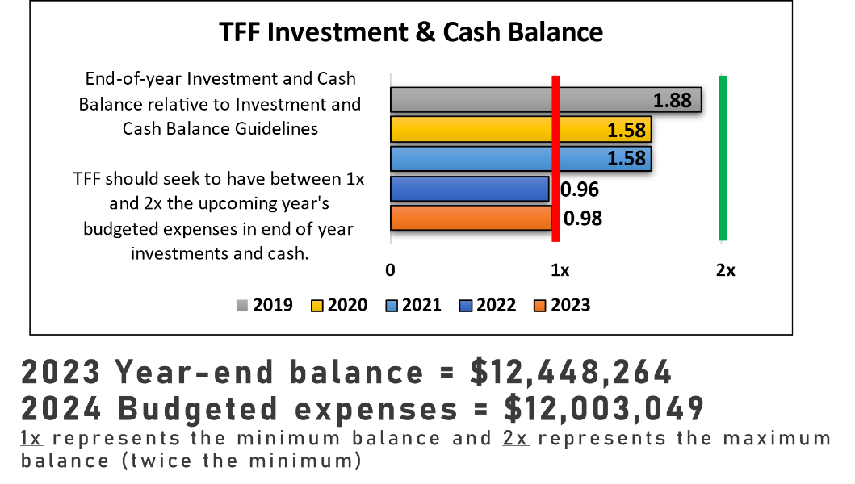  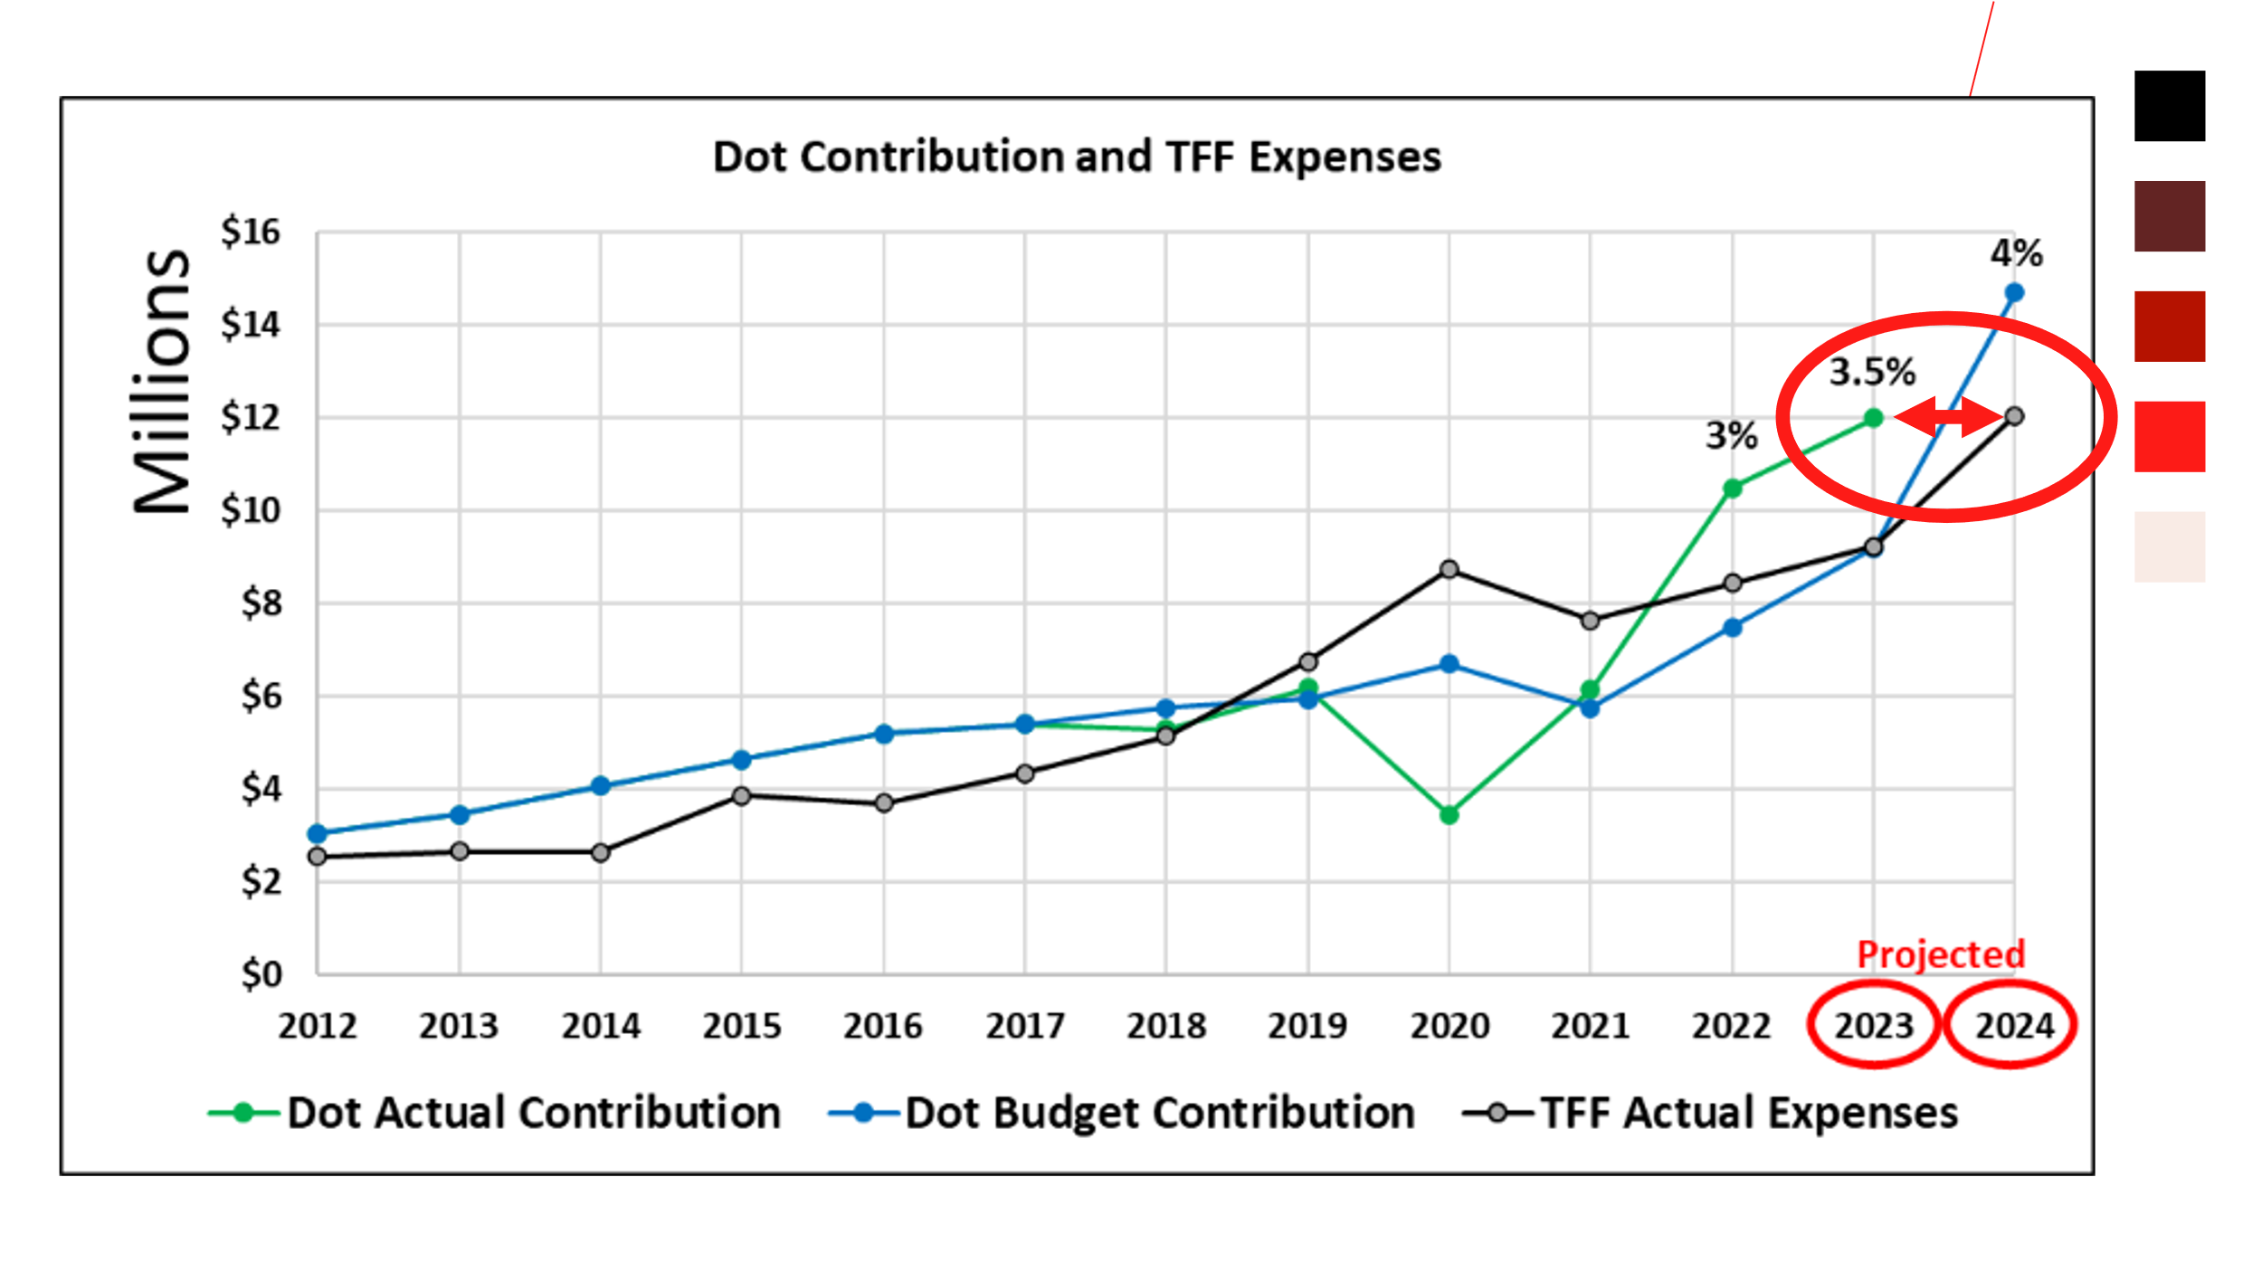  - 2023 Dot Contribution: $12M (March 2024)  - 2024 Dot Contribution: $14.7M
CONCLUSIONS | The Reserve Guidelines are still appropriate, but should be revisited periodically.
Action items |  | Person responsible | Deadline

2024 BUDGET: DAN
Discussion | Dan shared the TFF budget process, presented the 2024 TFF budget (including the changes that have been made since a draft budget was approved on 12/19/2024), and did a call for feedback/questions after each section.  SUMMARY OF PROPOSED 2024 BUDGET:  - Income: $15,326,247  - Less Grant Expenses: ($10,384,500)  - Less Direct Charitable and Operating Expenses: ($1,618,549)  - Surplus: $3,323,198  Below is a breakout of the Grant Program Expenses. GRANT PROGRAMS: $10,384,500  - Education: $2,615,500  - Brown County: $1,807,000  - Youth: $513,000  - Families: $701,000  - Mental Health: $615,000  - Capacity Building: $958,000  - Invitation Grants: $825,000  - Matching Grants: $2,165,000  - VIP Grants: $15,000  - Next Gen Grants: $170,000  Susie asked for a motion to approve the 2024 budget as Dan presented it today, with additional staff compensation changes that will be discussed during the Executive Session and at the Dot Family Director meeting.
CONCLUSIONS | Jim made a motion to approve the 2024 TFF budget as Dan presented it today, with additional staff compensation changes that will be approved during the Executive Session and Dot Foods board meeting. Jake seconded the motion. All voted in favor.
Action items |  | Person responsible | Deadline
Update the 2024 Budget once comp decisions are made. |  | Dan | 02/15/2024
Submit Payroll change for Dan. | Susie | 2/15/2024
Submit Payroll changes for all staff except Dan. | Dan | 2/15/2024

INVESTMENT REPORT: DAN
Discussion | Dan reported on TFF’s cash and investment accounts and did a call for feedback and questions.  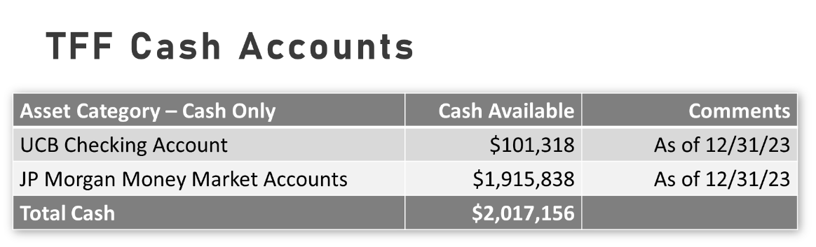  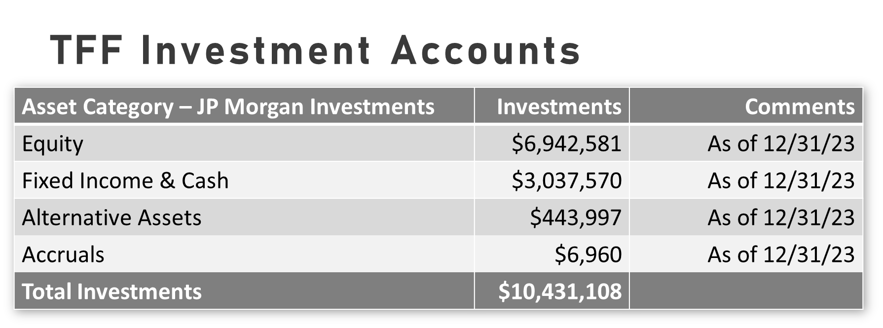  Dan shared the year-to-date TFF’s portfolio performance is 11.91%. He did a call for feedback and questions. There were no questions.

CONCLUSIONS
Action items |  | Person responsible | Deadline
Share more extensive benchmark comparisons at April meeting. |  | Dan | 04/25/2024

GRANT APPLICATION REVIEW & FUNDING DECISIONS: ANGIE & DAN
Discussion  And  CONCLUSIONS | Below are the applications reviewed today and the funding decisions.  FULL BOARD REVIEW:  DonorsChoose  Project: Classroom Matching Funds  Grant Request: $120,000 ($60,000 Spring/$60,000 Fall)  Board Decision: Linda made a motion to approve full funding, $120,000. Melanie seconded the motion. All voted in favor.  STAFF RECOMMENDATION APPLICATIONS:  The Modern Classrooms Project  Project: Modern Classrooms Project  Grant Request: $10,500  Staff Recommendation: $10,500  Board Decision: John made a motion to approve full funding, $10,500. Melanie seconded the motion. All voted in favor.  Jacksonville School District  Project: South Elementary – Ron Clark Academy  Grant Request: $17,500  Staff Recommendation: Up to $17,500. Note, this application has been amended, so actual check amount will be a little lower.  Board Decision: John made a motion to approve up to $17,500. Melanie seconded the motion. All voted in favor.  Quincy Public School District  Project: Ron Clark Academy  Grant Request: $76,000  Staff Recommendation: Up to $76,000  Board Decision: John made a motion to approve up to $76,000. Melanie seconded the motion. All voted in favor.  GRANT VARIANCES:  None to report  TFF STAFF DISCRETIONARY GRANTS – STAFF DECISIONS:  Facilitating Coordination in Agricultural Education  Project: IoT Agriculture Curriculum  Grant Request: $22,300  Staff Decision: Staff approved and awarded this grant for $22,300.  INVITATION GRANTS – STAFF DECISIONS:  Science Coach, Inc.: Operations - $15,000  A Precious Child: Edussentials - $15,000  Beyond Housing: Family Engagement Liaisons - $15,000  I Am More: Personal and Peer Development - $30,000  YOUTH TRIPS – STAFF DECISIONS:  Fellowship of Christian Athletes: College Mission Trip - Approved up to $12,500, pending final roster.  LIBRARY GRANTS – STAFF DECISIONS:  None to report

CONCLUSIONS
(SEE ABOVE)
Action items |  | Person responsible | Deadline
Process approved grants |  | Kim and Dan | 02/15/2024

3G OPPORTUNITY FUND: MEGAN
Discussion | 3G OPPORTUNITY FUND:  Megan provided background information on the 3G Opportunity Fund. Those serving on this committee are: Megan Costigan, Kristin Tracy, Maggie Sullivan, and Laruen Tracy.  The TFF staff selected the topic for this year, which is the impact of screen time on mental health. The 3G Opportunity Fund Committee found a program called Screen Sanity, based out of Kansas City. Screen Sanity focuses on creating tech-healthy kids in a digital age. TFF invited Screen Sanity to apply for a $100,000 grant in 2023. In December, the TFF board approved a $50,000 grant to Screen Sanity, with the potential for them to apply for another $50,000 in 2024.  Screen Sanity put together an updated request, which will focus on 3 Program Elements: 1. Foundational Resources. 2. Parent Night Events. 3. Digital Marketing. Megan provided additional information on each of the 3 program elements.  In April, TFF will launch an RFP to west central Illinois organizations, as well as specific contacts in St. Louis and Denver. The purpose of the RFP is to garner organizations to host the Parent Night Events. In May, organizations/schools will be selected to participate. May through October, Screen Sanity will provide virtual support to the selected organizations/schools in the planning of events. Events will occur at hosted sites in September/October 2024.  Feedback:  - Launch it first in west central Illinois so we can learn from the problems. Then take it to Denver/St. Louis.  - If we take it to Denver/St. Louis, make sure 3Gs in those regions are involved with their local communities on this.  - Continue with the plan to offer Screen Sanity in WC IL, Denver, and St. Louis since this is driven by 3Gs and we have a good number of 3Gs in those cities.  - When Screen Sanity has the marketing materials ready, they should be sent to all 2Gs and 3Gs in each of those communities.

CONCLUSIONS
Action items |  | Person responsible | Deadline
Supervise the launch of Screen Sanity in WCI and recruit family members to supervise launch in St. Louis and Denver. |  | Megan | Throughout 2024

POLICY REVIEW: JEAN
Discussion | MATCHING, NEXT GEN, AND INVITATION GRANT POLICIES: ELIGIBLE PARTICIPANTS - STEPCHILDREN  The conclusion from the December board meeting was that stepchildren of 2Gs and 3Gs should be eligible to participate in the TFF family grant programs. It was also concluded that we’re not going to address 4Gs at this time. There was little appetite for the “actively engaged” piece, because how do you measure that? Lastly, it was concluded that the stepparent should have legal custody of the child.  Suggested language in the policy: “Stepchildren in the legal custody of Robert and Dorothy Tracy direct descendant 2Gs and 3Gs before the age of 18 and legally adopted children of 2G and 3G direct descendants of Robert and Dorothy Tracy.” Jean asked if everyone agrees with these conclusions and this language. They did not. Jim offered to tweak this language, as well as the language for “Eligible Participants – Spouses of Stepchildren”. We will bring the policies back to the board in April with new language.  (Note: After the meeting, Jim Tracy suggested the following language: “Stepchildren in the legal custody of Robert and Dorothy Tracy direct descendant 2Gs and 3Gs that the spouse of this descendant has legal custody before the age of 18 and legally adopted children of 2G and 3G direct descendants of Robert and Dorothy Tracy.”)  Feedback:  - The way it is written says “stepchild of a descendant of RT and Dorothy”. The descendant of RT and Dorothy would not have legal custody, the person they married (the non-Tracy) would. Need to word it so the person the Tracy family marries has legal custody of the children.  - We wouldn’t want to have stepchildren as eligible participants if the person marrying into the family isn’t involved in the child’s life.  MATCHING GRANT POLICY: ELIGIBLE PARTICIPANT - PART-TIME STAFF  At the December meeting, there was not a lot of appetite for part-time staff to be eligible to participate in the Matching Grant Program. After some discussion, it was decided that part-time staff should not be eligible to participate in the Matching Grant Program.  MATCHING GRANT POLICY: PARTICIPANT ALLOWANCE  We will leave this as is for now ($60,000/participant), and will revisit in 2025 when we put together the 2025-29 Long Range Plan.  MATCHING GRANT POLICY: DOCUMENTATION OF PERSONAL DONATIONS  At the August meeting, the board discussed whether we should require documentation of personal donations for Matching Grants. The board concluded that we should start requiring documentation. Everyone still agrees with this approach. We will announce this change at the 2024 AFM. . It will be a requirement starting January 2025. This change may require some training for family members on how to upload a document to the portal.  MATCHING GRANT POLICY: ELIGIBLE PARTICIPANT MENTAL CAPACITY  At the December meeting, the board decided that a family member should remain as an eligible participant in the Matching Grant Program if they become mentally incapacitated, and their spouse should be the one to submit Matching Grant requests on their behalf. The board also decided that the grant application does not have to be consistent with their grantmaking prior to their incapacitation. Everyone still agrees with this approach.  At the December meeting, there was not much support from the board for an unmarried family member who becomes mentally incapacitated to remain eligible to participate in the Matching Grant Program, but no firm decision was made. After some discussion, it was decided that such family member would not be eligible to participate.  NEXT GEN GRANT POLICY: ELIGIBLE PARTICIPANT MENTAL CAPACITY  Jean asked for everyone’s feedback on this question: If an eligible participant in the Next Gen Grant Program becomes mentally incapacitated, should they remain eligible for program if they are able to attend a site visit with a guardian, parent, or spouse? After some discussion, it was decided that the family member should remain eligible, but we need to change the language to “parent, spouse, or sibling”.  INVITATION GRANT POLICY: ELIGIBLE PARTICIPANT MENTAL CAPACITY:  At the December meeting, most board members felt that an eligible individual who is married and is mentally incapacitated should remain as an eligible participant, and their spouse can participate on their behalf. The board also decided that the grant application does not have to be consistent with their past grant requests to TFF. Everyone still agrees with this approach.  CONFLICT OF INTEREST POLICY:  Jean shared summary of changes to the Conflict of Interest Policy and did call for questions.  GRANT AUTHORIZATION POLICY:  Jean shared summary of changes to the Grant Authorization Policy and did call for questions.
CONCLUSIONS | Matching Grant Policy: Part-time TFF staff are not eligible to participate in the Matching Grant Program.
 | Matching Grant Policy: Beginning January 2025, family members will be required to upload documentation of their personal donation when submitting a Matching Grant request.
 | Matching Grant Policy: A family member should remain as an eligible participant if they become mentally incapacitated, and their spouse should be the one to submit Matching Grant requests on their behalf. Grant application does not have to be consistent with their past grant requests to TFF.
 | Matching Grant Policy: Unmarried family members who become mentally incapacitated will not be eligible to participate in the Matching Grant program.
 | Next Gen Grant Policy: If an eligible participant becomes mentally incapacitated, they will remain eligible for the Next Gen Grant Program if they are able to attend a site visit with a parent, spouse, or sibling.
 | Invitation Grant Policy: An eligible individual who is married and is mentally incapacitated should remain as an eligible participant in the Invitation Grant Program, and their spouse can participate on their behalf. The grant application does not have to be consistent with their past grant requests to TFF.
 | Linda made a motion to approve the changes to the Matching, Next Gen, and Invitation Grant Policies. John seconded the motion. All voted in favor.
 | John made a motion to approve the changes to the Conflict of Interest Policy. Melanie seconded the motion. All voted in favor.
 | Tim made a motion to approve the changes to the Grant Authorization Policy. Jake seconded the motion. All voted in favor.
Action items |  | Person responsible | Deadline
Tweak language in Matching, Next Gen, and Invitation Grant Policies related to Stepchildren, and Spouses of Stepchildren. |  | Jim | 04/01/2024
Change language in policies where needed, as outlined above. |  | Jean | 04/01/2024
Bring updated Matching, Next Gen, and Invitation Grant Policies to board at April meeting for final review and approval  Share with the family that Matching Grant donation documentation will be required starting January 2025. |  | Jean  Jean or Susie | 04/25/2024  05/02/24

FOCUS AREA UPDATE – BROWN COUNTY: DAN & SUSIE
Discussion | MT. STERLING 2024-33 STRATEGIC PLAN – DAN:  Dan shared the selection process steps that led to TFF hiring a consultant for the Mt. Sterling 2024-33 Strategic Plan. TFF is engaging 3 consultants to work together: Teska, Small Nation, and All Together. Teska will take the lead on the plan. Small Nation has experience with small town redevelopment work and will work as a sub-consultant. All Together will work as a sub-consultant as well, doing the marketing/branding/social media mechanism.  Work to Date:  - RFPs issued and consultants selected  - Steering Committee meetings have taken place  - Popup event held at Brews Coffee in Mt. Sterling  - Strategic team completed SOAR analysis  - In-person interviews conducted with 15 people in Mt. Sterling, Zoom interviews with another 7, and more to come  Dan shared some of the findings from this work to date. He also shared the website All Together designed: www.helloinput.org/mountsterling. People can interact with the content, share ideas and input, etc.  There is another event planned at Hagel in March. It will be a workshop with engagement opportunities for the public. The next Steering Committee meeting is in March. All interview data and research will be consolidated by then, and the committee will start to develop strategies.  BC TRAILS – ENGINEERING GRANT APPLICATION – DAN:  The board had a robust conversation around the Brown County Trails project during the December conference call. Dan provided a brief overview today for the new trustees. Clark Park Loop Trail is the first trail we started with. It is complete except for asphalt, which will be laid in the spring. The next phase is to potentially connect the Clark Loop Trail to a potential new Mt. Sterling Lake Trail. For this trail to become a reality, the first steps in the process are to secure easements from two property owners and to hire an engineering firm. The board discussed both the easements and engineering at the December board meeting. Dan provided the following information which addressed questions and concerns raised at the December meeting.  Questions from December:  - Liability: Dan consulted with an attorney through Exponent Philanthropy (Andras Kosaras – Arnold & Porter out of Washington, DC) on liability not just for the trails, but any higher-risk project TFF provides funding for (ELC, The Rink, trails, etc.). Andras doesn’t know of any case where a foundation has been found liable for an injury that happens on a project funded by a foundation. TFF would provide the grant to another entity, we wouldn’t pay for it directly. We would ensure the public entity we grant to makes the design and engineering decisions, and that they have appropriate liability insurance. We would also ensure the other entity signs all engineering and construction agreements. They would be the client and would own the trails/project. The highway crossing must be approved by IDOT, so the crossing itself would be state owned.  - Engineering Options: What Dan presented in December was for Phase I on the Lake Trail, totaling $125,000. This included engineering from the Lake Trail from Clark Park to the Mt. Sterling Lake. It included crash and traffic study, topography and elevation study, utility coordination, environmental, pavement design, public input, etc. The board asked Dan to investigate a pared down option, just for the easements. Dan secured a quote from Hutchinson, which came in at $38,000 to do the easement plats. This includes drainage and construction limits, easement boundaries, land survey, easement plats, and legal documents. It does not include legal for securing easements, easement recording, etc. The preliminary engineering will make TFF’s ITEP application stronger.  Recommended Board Action: Dan asked the board to approve a grant of up to $45,000 to Brown County to have Hutchinson Engineering, Inc. provide easement plats to allow Brown County to secure permanent easements, and for legal support.  Linda made a motion to approve up to $150,000 for the Brown County Trails Project, giving Dan discretion for disbursement of grant funds for engineering costs, etc. for the rest of the trail project. John seconded the motion. All voted in favor.  BC EARLY LEARNING CENTER & DOROTHY TRACY EDUCATION CENTER – DAN:  Dan provided an update on the Brown County Early Learning Center and did a call for feedback and questions.  Dan asked for a motion to approve 2024 grants to DTEC and BCELC.  Note: Jean and Jim abstained from voting as they are directors on both of these boards.  - Grant to DTEC: Up to $30,000 for taxes and maintenance. John made a motion to approve a grant of up to $30,000 to the Dorothy Tracy Education Center for taxes and maintenance. Melanie seconded the motion. All voted in favor.  - Grant to BCELC: Up to $272,500 for the operating subsidy. John made a motion to approve a grant of up to $272,500 to the Brown County Early Learning Center for the operating subsidy. Jake seconded the motion. All voted in favor.  DOROTHY TRACY ESTATE GIFT – DAN:  Dan provided an update on the Dorothy Tracy Estate Gift and did a call for feedback and questions.  Dorothy’s Original Gift: $1,854,426  Grants awarded to date:  - $99,998 – St. Mary School Windows  - $331,570 – Holy Family Renovation  - $250,000 – Joel Oliver Memorial Swimming Pool  - $27,768 – Mt. Sterling YMCA Roof Repairs  Remaining Balance: $1,145,090  JOEL OLIVER POOL – DAN:  Dan provided an update on the Joel Oliver Pool and did a call for feedback and questions. TFF provided a $250,000 grant for pool renovations. The Park District has a $400,000 grant from the State of Illinois for the project. TFF also provided a 1:1 Challenge Grant of up to $150,000 and the Park District met the challenge.  BROWN COUNTY PUBLIC LIBRARY – DAN:  Dan provided an update on the Brown County Public Library and did a call for feedback and questions. The new library building is well under construction. Everything is going along as expected and construction is expected to be finished by the end of the year. The library will likely come to TFF for funding items inside the building, such as furniture.  ICE RINK – DAN AND SUSIE:  Dan provided an update on The Rink and did a call for feedback and questions. The Rink was open from Thanksgiving through early January. There were 4,211 skaters during public hours (over 5,000 skaters if you include 9 private parties). This well surpassed our expectations. The Rink brought in $70,000 in revenue. Rink installation, rental, and tear-down was $82,000. Electric was around $60,000. Several other expenses were incurred, but these were one-time expenses. Action Brown County will rent the Rink again next year and will talk about purchasing it after next season.  FUTURE BIG PROJECT DISCUSSION – DAN:  Dan provided an update on Big Project Ideas and did a call for feedback and questions.  Feedback:  - Ensure that we retain walkability with any new projects in Uptown MS.  - Share Big Project Ideas information again at the AFM. Give family opportunity to vote things off and/or add more.  - TFF Office needs to be a priority, especially since we are adding more TFF staff down the line.  - Probably a good idea to do another assessment to see what big project ideas are going on within 50 miles of Mt. Sterling so we can make sure we’re not duplicating.  - Is there an opportunity to enhance public transportation through the West Central Mass Transit District?
CONCLUSIONS | Linda made a motion to approve up to $150,000 for the Brown County Trails Project, giving Dan discretion for disbursement of grant funds. John seconded the motion. All voted in favor.
 | John made a motion to approve a grant of up to $30,000 to the Dorothy Tracy Education Center for taxes and maintenance. Melanie seconded the motion. All voted in favor.
 | John made a motion to approve a grant of up to $272,500 to the Brown County Early Learning Center for the operating subsidy. Jake seconded the motion. All voted in favor.
Action items |  | Person responsible | Deadline
Move forward with the approved scope of work for the Mt. Sterling Lake Trail |  | Dan | 12/31/24

TRACY FAMILY PHILANTHROPIC PLATFORM: JEAN
Discussion | Jean provided background information on the Tracy Family Philanthropic Platform. TFF has engaged a consultant, Boldy Go Philanthropy, to help think through the potential framework and to help us decide if we should move forward.  Boldy Go has reviewed background materials, facilitated Steering Committee workshops, conducted family and staff interviews, and distilled interview findings. They have also interviewed and researched other multi-generational families. Through their research, interviews, meetings, Boldy Go made a preliminary recommendation. They recommend we start this with a pilot program for 1-2 years and go from there, depending on how things go. The recommendation is in the process of being tweaked, but the tiered approach really resonated with a lot of people. Jean shared info on how this would be staffed and overseen, as well as cost options for different services. Some services would have no charge, some would have subsidized charges, and others would have billed services.  Boldy Go is currently making refinements to their recommendations based on their conversations last week. The Steering Committee, TFF board, and Dot Family Directors will review and discuss the recommendation from Feb – April. The plan is to make a decision on the recommendation by May 2024.

CONCLUSIONS
Action items |  | Person responsible | Deadline
Extend the 2/5 and 2/12 Boldly Go Zoom mtg invitation to the Board.. |  | Jean | February 1, 2024
Continue working on this project until a conclusion is reached. |  | Jean | 2024

NEXT TFF BOARD MEETING DATES: SUSIE
Discussion | - April 25, 2024: Dot Foods – Chesterfield, MO  - July 25, 2024: Dot Foods – Mt. Sterling, IL  - December 6, 2024: Dot Foods – Mt. Sterling, IL
CONCLUSIONS | We will likely start scheduling board meetings a bit differently. Going forward, we may try scheduling the following year’s board meeting at the current board meeting. For example, we would schedule the April 2025 board meeting at the April 2024 board meeting.
Action items |  | Person responsible | Deadline
Let Susie know Innovations date for 2024. |  | Jake | ASAP
Figure out January and April 2025 board meeting dates. |  | Susie/Board | April board meeting
Decide location of April 25, 2024 board meeting. |  | Susie | ASAP
Discuss changing board meeting dates (i.e. moving January meeting so we don’t have December/January meetings back to back, and gives more time for previous year financials). |  | Board | April board meeting

ADJOURN: SUSIE
Discussion | Susie asked for a motion to adjourn the board meeting.
CONCLUSIONS | Jim made a motion to adjourn the meeting at 3:00 p.m. John seconded the motion. All voted in favor.
Action items |  | Person responsible | Deadline

AN EXECUTIVE SESSION WAS HELD IMMEDIATELY FOLLOWING THE BOARD MEETING. THERE ARE SEPARATE MINUTES FOR THE EXECUTIVE SESSION.

SUBMITTED BY (TFF ADMIN): | Kim Bielik
APPROVED BY (TFF SECRETARY):

APPROVED BY (TFF BOARD CHAIR):

