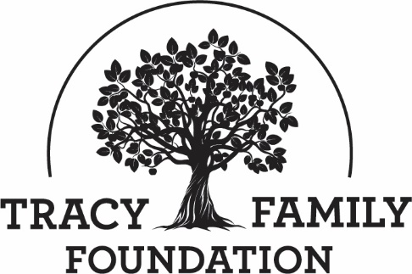

Tracy Family Foundation Board Meeting Minutes

DATE: | February 8, 2022
TIME: | 11:00 – 12:00 pm CST
LOCATION: | Zoom
TRUSTEE ATTENDEES: | Jean Buckley, Susie Stamerjohn, Wanda Tracy, Ben Tracy, Kristin Tracy, Linda Tracy, Kenzie Tracy, Mark Yingling, Sam Sullivan, Tim Curtin
MINUTES/STAFF ATTENDEE: | Kim Bielik
TFF STAFF ATTENDEE: | Dan Teefey

WELCOME & OPENING PRAYER: JEAN & LINDA
Discussion | Jean welcomed everyone to the call. Linda opened the call with a prayer. Thank you, Linda!

CONCLUSIONS
Action items |  | Person responsible | Deadline
Assign someone to open the next board meeting with a prayer. |  | Linda | 04/01/2022

ABOUT ROBERT & DOROTHY TRACY: JEAN
Discussion | Jean shared a story about RT and Dorothy.  You can tell a lot about a person by looking at their checkbook. How and where a person spends their money shows what’s important to them. When Dorothy started needing assistance with her charitable giving, Jean used Dorothy’s checkbook as a guide to help decide where Dorothy would want her money to go. In looking back at her giving over the last few years, there were about 4-5 organizations Dorothy wrote checks to year after year. She was very loyal in her giving. The clear winner in terms of where her money went to was Holy Family Church in Mt. Sterling. Dorothy’s checkbook certainly showed that she and RT were grounded in their faith. Faith was not only important to RT and Dorothy, it is also a core value of the Foundation.
Action items |  | Person responsible | Deadline

APPROVE MINUTES: JEAN
Discussion | Jean asked for separate motions to approve the 11/22/2021 and 12/17/2021 board minutes.
CONCLUSIONS | Ben made a motion to approve the 11/22/2021 minutes. Wanda seconded the motion, and all were in favor.  Linda made a motion to approve the 12/17/2021 minutes. Susie seconded the motion, and all were in favor.
Action items |  | Person responsible | Deadline

2021 WRAP-UP: DAN AND KRISTIN
Discussion | Q4 2021 DASHBOARD: DAN  Dan shared the Dashboard slides, made a few comments, and did a call for questions. Trustees were encouraged to let Dan and Jean know if there are other Key Performance Indicators that they would like tracked.  2021 YEAR-END FINANCIALS: KRISTIN  Financials today are through December 31, 2021. Below is a summary.  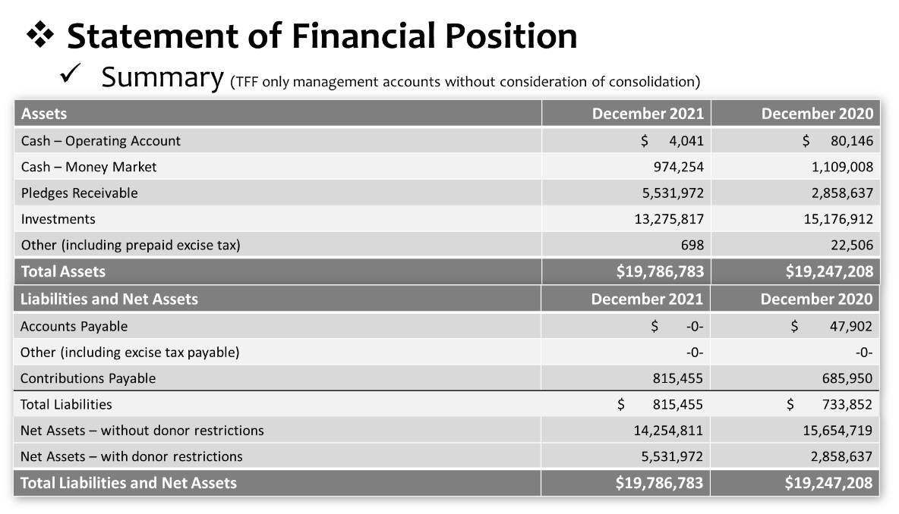  Commentary:  - Cash: Operating Account is lower than 2020 due to the timing of moving money from Money Market account.  - Contributions Payable: This is grants approved in 2021, but not yet paid out. Examples of large Contributions Payable: $111K for Communio Marriage Project, $50K for The Crossing Marriage Retreat Center, $350K for BC Library, $100,050 for BC Trailways engineering work, et al.  ____________________________________________________________________  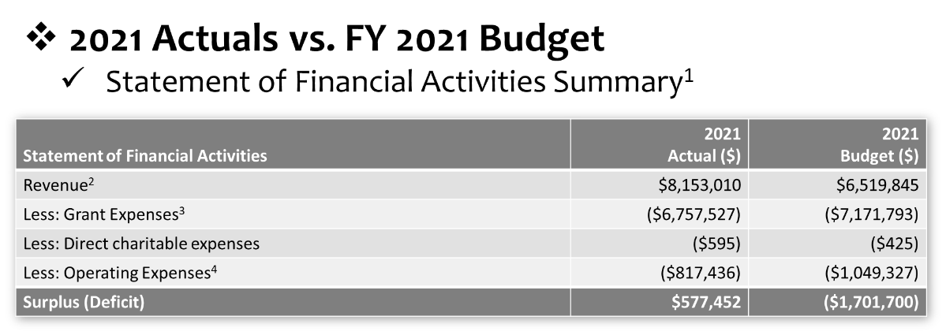  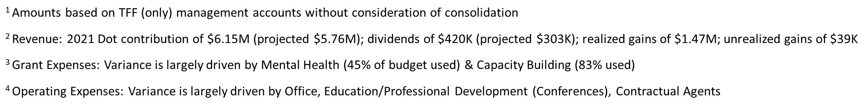  Commentary:  - TFF had a surplus for the year driven by: Dot contribution larger than expected, more investment income, and less operating expenses.  - Overall, grant expenses were pretty in line with the budget. The largest variances were in Mental Health (still working on developing plans for this new Focus Area, the Mental Health grant expenses will increase in 2022), Capacity Building (mostly driven by effects of Covid and some projects that didn’t pan out or were done on a smaller scale), and Brown County (schools didn’t request as much as we anticipated, and not as many scholarships were awarded).

CONCLUSIONS
Action items |  | Person responsible | Deadline

2022 BUDGET: DAN
Discussion | Dan shared the TFF budget process and presented the 2022 TFF budget, including the changes that have been made since a draft budget was approved on 12/17/21. He noted that there will be additional changes to Staff Comp and Benefits once final compensation decisions are made during the Board Executive Session.  2022 Budget Process:  - Compiled financial projections (each staff person provided input on their areas of responsibility)  - TFF Board approved a draft 2022 budget on 12/17/21  - Seeking approval of the 2022 budget today  Dan walked through the budget and did a call for questions after each section.  Highlights of Income, Grant Programs, and Operating Expenses are as follows:  INCOME:  - The Dot contribution is significantly higher than we anticipated. We originally budgeted $5.3M, but the contribution is going to be $6.15M. We anticipated a significant deficit ($1.7M), but wound up with only a $300,000 deficit (which we had assets to cover).  - The Total Income projected is $8,175,750. This is an 25% increase from the 2021 budget. $7,500,000 of the income is projected to come from Dot Foods.  GRANT PROGRAMS:  We remain pretty level across our grant programs. A few things to note:  - YOUTH: There is a significant budget increase in Youth. This is accounting for the raise from $10K to $15K for all eligible Invite Program participants, and collaboratives in Jacksonville, Beardstown, and possibly Macomb.  - MENTAL HEALTH: Increase here because we are trying to grow this program in 2022.  - CAPACITY BUILDING: Increase due to new programs.  - COVID-19 RESPONSE FUND: Nothing budgeted for 2022.  - Grant expenses total $7,257,401. This is a 1% increase from 2021.  OPERATING EXPENSES:  - Operating expenses are up about 17%. A good chunk of that is a new hire for a TFF Finance Manager.  - Direct Charitable Expenses (dollars we pay for-profit entities for Direct Charitable Activity): 2022 budget is $3,095.  - The Direct Charitable and Operational Expense budget for 2021 is $1,222,986.  Summary of Proposed 2022 Budget:  - Income: $8,175,750  - Less Grant Expenses: ($7,257,401)  - Less Direct Charitable and Operating Expenses: ($1,222,986)  - (Deficit) = ($307,732)  Jean asked for a motion to approve the 2022 budget as Dan presented it today, with the updated 2022 Staff Compensation and Benefits dollar amount that is approved during the Executive Session today.
CONCLUSIONS | Mark Yingling made a motion to approve the 2022 TFF budget with the updated 2022 Staff Compensation and Benefits dollar amount that is approved at the 2/8/22 Executive Session. Kristin seconded the motion, and all were in favor.
Action items |  | Person responsible | Deadline
Update 2022 Budget |  | Dan | 2/20/22

GRANT APPLICATION REVIEW, UPDATES, & FUNDING DECISIONS: JEAN & DAN
Discussion | The board discussed the following three requests and made decisions:  - Organization| Brown County Public Schools District  Project: NWEA MAP Assessment  Grant Request: $3,662.50  - Organization| Donors Choose  Project: Teacher Support  Grant Request: $100,000  - Organization| Mindful Philanthropy  Project Name: Mental Health Advisory Services  Grant Request: Up to $50,000
CONCLUSIONS | Wanda made a motion to approve a $3,662.50 grant to Brown County Public Schools for the NWEA MAP Assessment, a $100,000 grant to Donors Choose for Teacher Support, and up to $50,000 to Mindful Philanthropy for Mental Health Advisory Services. Dan & Jean were authorized to make the final funding decision for the Mindful Philanthropy request. Susie seconded the motion, and all were in favor.
Action items |  | Person responsible | Deadline
Process approved grants |  | Kim and Dan | 03/01/2022

ADJOURN: JEAN
Discussion | Tim made a motion to adjourn the meeting at 12:15 p.m. Linda seconded the motion, and all were in favor.

CONCLUSIONS
Action items |  | Person responsible | Deadline

AN EXECUTIVE SESSION WAS HELD IMMEDIATELY FOLLOWING THE BOARD MEETING. THERE ARE SEPARATE MINUTES FOR THE EXECUTIVE SESSION.

SUBMITTED BY (TFF ADMIN): | Kim Bielik
APPROVED BY (TFF SECRETARY):

APPROVED BY (TFF PRESIDENT):

