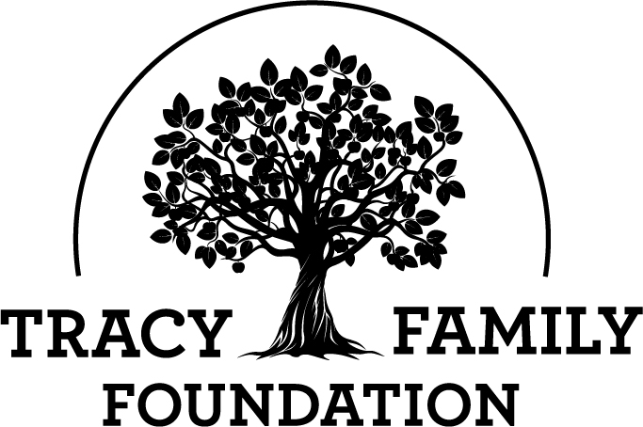

Next Generation Advisory Board

Meeting Minutes

Minutes: | March 22, 2022 |  | location: Zoom
6-7 PM CST

ATTENDEES | Kelsey Cope (Chair), Ari Buckley (Vice-Chair), Alex Tracy (Secretary), Kelsey Tracy, Kendra Stamerjohn, Megan Costigan (TFF Advisor)
MINUTES | Alex Tracy

GUEST SPEAKERS

Welcome |  |  |  | Kelsey Cope

Discussion
Kelsey welcomed everyone.

Conclusions
Action items |  |  |  |  | Person responsible |  |  | Deadline

Grant Reviews |  |  |  | Ari Buckley

Discussion
- Carrollton Public Library
  - Family Story Kits and Children's Area Organization/Expansion - $5,000
  - Used prior funding for younger ages
  - Education for ages 5-8
  - 3rd grade is an important age to be able to read
  - All voted full funding
- Four Star Public Library District
  - Early Childhood Technology - $5,000
- Money will be used for a Kaplan interactive panel
- Have received prior money from the TFF, last in 2019.
  - All voted full funding
- Pittsfield Public Library
  - Permanent Story Walk - $5,000
  - Never received funding from TFF.
  - Should get families outside and get their kids learning.
  - All voted full funding
- Rushville Public Library
  - Read Beyond the Beaten Path - Summer Reading 2022 - $5,000
  - They have received 2 grants($5k) 2018 and 2019, and one capacity building grant($1,271) in 2018
  - TFF needs more information on the budget.

Conclusions
Full funding for 3 out of the 4 organizations requesting grants. One needing more information.
Action items |  |  |  |  | Person responsible |  |  | Deadline
Megan to get updated budget and more info on the specifics of the Rushville Public Library Summer Reading program. |  |  |  |  | Megan Costigan |  |  | Within the week

Special Impact Grant (SIG) |  |  |  | Kelsey Cope

Discussion
- Values Exercise – Megan summarized the results from the 5 survey responses. There was a consistent theme on helping children/youth throughout each survey response. The focus areas of health, nutrition, education and substance abuse/addiction were also noted many times. After some discussion, the group is leaning towards helping children/youth with a focus on health and nutrition with a potential emphasis on the education of it.

Conclusions
More thought needs to be done, with votes needed by 3/28/22
Action items |  |  |  |  | Person responsible |  |  | Deadline
Megan will research a few organizations and/or programs that are helping youth nutrition and health so NGAB members have a better idea of examples of what organizations and programs the SIG funding could impact. |  |  |  |  | NGAB members will email Kelsey and Megan their top 1-2 votes for the 2022 SIG focus area. |  |  | 3/28/2022

3G/4G Family Grant Participation |  |  |  | Megan Costigan

Discussion
- Current participation
  - 4G Next Gen - 17%
  - 3G Next Gen - 10%
  - 3G Matching - 22%
  - 3G Invitation - 14%
- Everyone will get a magnet to put on fridge, with deadlines and grant info
- Send people to Megan if they need help.

Conclusions
Action items |  |  |  |  | Person responsible |  |  | Deadline
- All NGAB members should continue to remind the 3Gs/4Gs to participate in the grant programs they’re eligible for this year |  |  |  |  | All NGAB members

TFF Topics |  |  |  | Megan Costigan

Discussion
- 4G childcare at TFF Retreat and Dot Shareholder Meeting
  - Would you be interested in this?
  - What would your expectations be?
  - Is there any info that would help you decide if you want to use this service?
- We have in our budget to create a children's book this year. We’ve done some initial research, but would like your feedback on what you think this should or could look like. What do you imagine when you think of a TFF children’s book?
    - RT and Dorothy
    - Dot trucks
    - Story of Dot using illustrations not actual photos
    - Board book
    - Two books - one for dot, one for TFF
    - Incorporate textures
    - Untold Stories about dot, the family, TFF… book for the older kids…

Conclusions
Action items |  |  |  |  | Person responsible |  |  | Deadline
Think of ideas on what you imagine when you think of a TFF children’s book. |  |  |  |  | All NGAB Members

