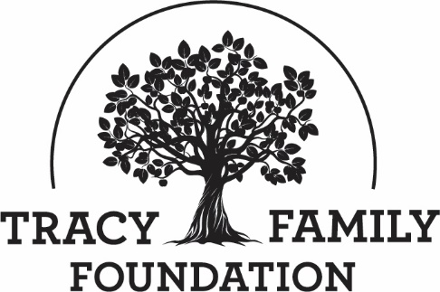

Tracy Family Foundation Board Meeting Minutes

DATE: | December 19, 2022
TIME: | 11:30 – 1:00 pm CST
LOCATION: | Zoom
TRUSTEE ATTENDEES: | Jean Buckley, Susie Stamerjohn, Wanda Tracy, Ben Tracy, Kristin Tracy, Tim Curtin, Mark Yingling, Kenzie Tracy, Sam Sullivan, Linda Tracy
MINUTES/STAFF ATTENDEE: | Kim Bielik
TFF STAFF ATTENDEE: | Dan Teefey

WELCOME & OPENING PRAYER: JEAN & KENZIE
Discussion | Jean welcomed everyone to the call. Kenzie opened the call with a prayer. Thanks Kenzie!

CONCLUSIONS
Action items |  | Person responsible | Deadline
Assign someone to open the next board meeting with a prayer. |  | Jean | 1/15/2023

APPROVE 12/2/2022 EXECUTIVE SESSION MINUTES: JEAN
Discussion | Jean asked for a motion to approve the 12/2/2022 Executive Session Minutes.
CONCLUSIONS | Linda made a motion to approve the 12/2/2022 Executive Session Minutes. Wanda seconded the motion, and all were in favor.
Action items |  | Person responsible | Deadline

ABOUT ROBERT & DOROTHY TRACY: JEAN
Discussion | Jean shared a Christmas story about RT’s sister, Mary Ellen. Aunt Mary Ellen would send the Tracy kids a box of books for Christmas each year. At the time, Jean thought it was a pretty boring Christmas present for a kid! Now as an adult, when she reflects on this gift, Jean is so grateful for RT, Dorothy, and Aunt Mary Ellen, who all helped instill in the 12 kids the importance of education and reading. Cheers to RT, Dorothy, and Aunt Mary Ellen!
Action items |  | Person responsible | Deadline

NOVEMBER 2022 FINANCIAL UPDATE: KRISTIN
Discussion | Kristin provided a financial report with updates on what has changed through November.  Total Assets: $11.6M  $2M in cash was raised from the TFF investment portfolio through November 2022. Total ending cash position for all cash accounts: $2.2M.  No changes to Liabilities, except net income (-$600K).  Total YTD Income: -$1.2M  - Dividend & interest income of $74K in November.  - Realized losses of $12K in November.  - Total YTD unrealized losses were $5.2M, now $4.6M.  Total YTD Expenses: $6.6M  - Grant Expenses: At 81% of budget.  - Operating Expenses: At 67% of budget.

CONCLUSIONS
Action items |  | Person responsible | Deadline

GRANTS: DAN
Discussion | THE FAMILY DINNER PROJECT  The Family Dinner Project (TFDP) is a proactive TFF project in West Central Illinois. Dan provided an overview and explained how TFF is working with TFDP. TFF sends out RFPs to recruit organizations to participate in this project. The below organizations submitted grant applications:  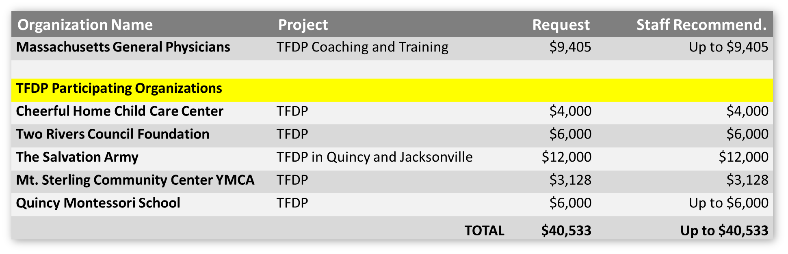  Massachusetts General Physicians administers the program for us. TFF Staff is recommending full funding for all, except for Quincy Montessori School (need more details on their app, recommending approve up to $6k).  Dan asked for a motion to approve the Family Dinner Project grant applications. Wanda made a motion to approve the Family Dinner Project grant applications. Susie seconded the motion, and all were in favor. Mark did not vote because he is on the Two Rivers Foundation Board.  STAFF DISCRETIONARY, YOUTH TRIP, AND INVITATION GRANT REPORT  Staff Discretionary:  Reviewed by TFF Staff. Approved by TFF Executive Director & TFF Board President.  - Transitions: $9,650  - Mindful Philanthropy – Additional $2,000 (scope of work increased beyond TFF Board’s original approval – now a total of $56K for the project)  No board action required on Staff Discretionary Grants.  Youth Trip:  Reviewed by TFF Staff. Approved by TFF Executive Director.  - Blessed Sacrament Catholic School: Up to $6,450  - Quincy University: $1,500  No board action required on Youth Trip Grants.  Invitation Grant:  Reviewed by TFF Staff. Approved by TFF Executive Director.  - Voices for Children of Tampa Bay: $30,000  - Beyond Housing: $15,000  - SOS Children’s Villages of Illinois: $30,000  - Elevate St. Louis: $15,000  - The Outlet: $15,000  - St. Louis ARC: $30,000  - Friends of the Finland Community: $30,000  - Prosperity Connection: $15,000  No board action required on Invitation Grants.
CONCLUSIONS | Wanda made a motion to approve the Family Dinner Project grant applications. Susie seconded the motion, and all were in favor. Mark did not vote because he is on the Two Rivers Foundation Board.
Action items |  | Person responsible | Deadline

2023 DRAFT BUDGET: DAN
Discussion | The 2023 draft budget was sent to trustees for review prior to today’s call. Today Dan walked trustees through the process and the budget.  Dan explained the TFF budget process. He then reviewed the 2022 actuals (through November) and presented a draft 2023 budget for approval. Dan will present the final 2023 TFF budget for board approval at the January 30, 2023 board meeting.  Some questions were raised about the reasoning for including net realized/unrealized gains/losses in the income section of the budget. Jean shared that a discussion about net realized/unrealized gains/losses pops up every few years, usually centered on the percent that is budgeted for this line item. Jean and Dan will get an opinion from JP Morgan as to whether they feel net realized/unrealized gains/losses should be included in the TFF budget and if so, what amount is reasonable. We will discuss again at the January board meeting.  2023 BUDGET SUMMARY:  - Projected Income: $10,268,108  - Projected Expenses: $9,814,285  - Projected Surplus: $453,823  Income Details:  - Dot Foods contribution: $9,800,000  - Interest & Dividends: $182,443  - Net Realized/Unrealized Gains: $273,665  - Trustee Fee Donations: $12,000  - Refund of Grants: $0  - TOTAL INCOME: $10,268,108  Expense Details:  Program & Grant Expenses  - Total Education: $1,943,326  - Total Brown County: $1,701,285  - Total Youth: $315,000  - Total Families: $302,500  - Total Mental Health: $370,000  - Total Capacity Building: $803,500  - Total Invitation Grants: $825,000  - Total Matching Grants: $2,075,000  - Total VIP Grants: $15,000  - Total Next Gen Grants: $230,000  - Total Direct Charitable Expenses: $595  Operating Expenses:  - Accounting/Auditing Expense: $15,200  - Admin Expense: $7,200  - Advertising/Marketing: $15,000  - Bank Charge: $200  - Board and Family Retreat: $0  - Contractual Agents: $9,000  - Grants Management Software (Cybergrants): $30,000  - Director Fees: $70,600  - Insurance: $3,500  - Education & Conferences (Professional Development): $38,725  - Meeting Expense: $15,850  - Membership Dues: $5,420  - Miscellaneous: $3,000  - Office: $50,300  - Office Supplies: $3,250  - Payroll Taxes: $47,941  - P.O. Box Rent: $65  - Professional Fees: $51,000  - Publications: $15,000  - Staff Comp & Benefits: $803,033  - Tax & Filing Fee: $6,000  - Technology Expense: $22,450  - Travel Expense: $19,750  Items to Note:  - Staff Comp & Benefits and Payroll taxes will be finalized at TFF’s January 30 Board meeting once staff reviews are complete.  TOTAL GRANTS, DIRECT CHARITABLE, & OPERATING EXPENSES: $9,814,285  TOTAL INCOME: $10,268,108  Surplus of $453,823  After questions and discussion, Jean asked for a motion to approve the 2023 draft budget, with the understanding that a final 2023 budget will be presented for approval at the January 30, 2023 board meeting.
CONCLUSIONS | Tim made a motion to approve the 2023 draft budget as Dan has presented it today. Ben seconded the motion, and all were in favor
Action items |  | Person responsible | Deadline
Present a final 2023 budget to board for approval. |  | Dan | January 30, 2023
Discuss the annual grant that TFF makes to the YMCA of West Central IL for the services they provide to the Mt. Sterling YMCA. Should this still be an expense paid by TFF? If yes, is the grant amount still appropriate? |  | Jean | January 30, 2023
Get opinion from JP Morgan on listing net unrealized/realized gains/losses in the income section of the budget. Discuss with board in January. |  | Dan and Jean | January 30, 2023

FAREWELL TO EXITING TRUSTEES: JEAN
Discussion | Today is the last board meeting for Sam, Wanda, and Kenzie. We will miss you all! Thank you for your dedication and service!

CONCLUSIONS
Action items |  | Person responsible | Deadline

ADJOURN: JEAN
Discussion | Sam made a motion to adjourn the meeting at 1:00 p.m. Kenzie seconded the motion, and all were in favor.

CONCLUSIONS
Action items |  | Person responsible | Deadline

SUBMITTED BY (TFF ADMIN): | Kim Bielik
APPROVED BY (TFF SECRETARY):

APPROVED BY (TFF PRESIDENT):

